Background Reading for Teachers

This information aims to provide educators with foundational knowledge on the causes and effects of ocean and coastal acidification. It also provides a comparison of coastal acidification and ocean acidification. The sections on ocean chemistry and the difference between ocean acidification and coastal acidification are recommended in particular.
1. The Carbon Cycle
2. Ocean Chemistry & pH
3. Coastal Acidification vs. Ocean Acidification
4. Biological Impacts
5. Key Terms
Additional Resources

The Carbon Cycle
Carbon is the fourth most abundant element in the universe and is present in every living thing (as well as most non-living things). Carbon naturally flows between rocks, the ocean, plants, the atmosphere, soil, and fossil fuels through biological and physical processes. Although carbon is always moving between different parts of the Earth and the environment, the carbon cycle maintains a balance over the long term that keeps the temperature of the Earth relatively stable.

Carbon dioxide (CO₂) is a form of carbon that has existed naturally in Earth’s atmosphere for millions of years. CO₂ plays an important part in many natural processes and cycles through living things, the soil, the atmosphere, and the oceans. CO₂ concentrations in the atmosphere fluctuated over time but stayed below 300 parts per million until the Industrial Revolution.

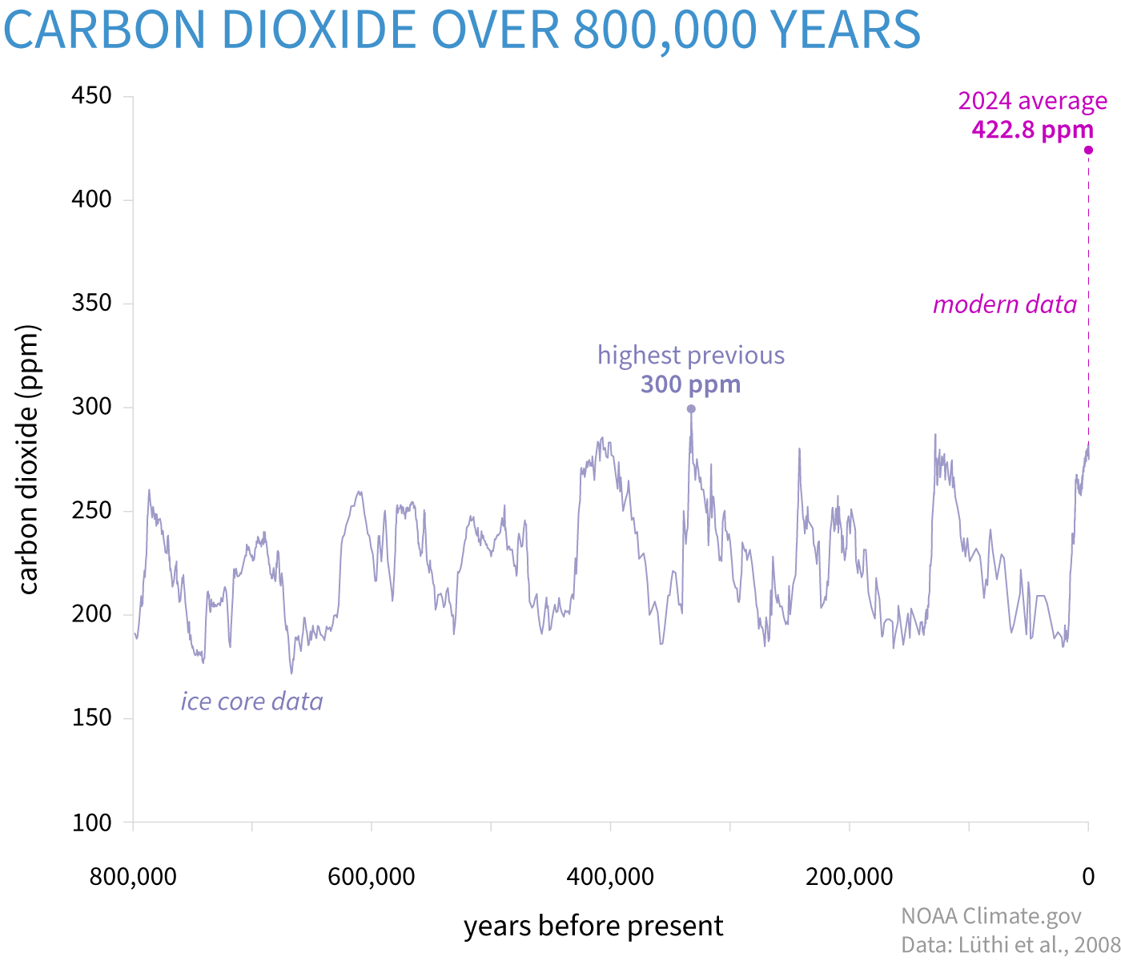
Figure 1:NOAA graph depicting the breakdown of CO₂ emissions as compared to carbon sinks.

In the 1800s, humans rapidly urbanized and industrialized by mining coal, cutting down trees, and burning fossil fuels. Forests and fossil fuels naturally sequester and store carbon, so the consumption of these materials so quickly caused an increase in atmospheric CO₂. In the past, a sudden increase of carbon dioxide in the atmosphere, like a volcanic eruption, would be self-corrected by the carbon cycle. Excess CO₂ in the atmosphere would move to other carbon sinks and the amount of atmospheric CO₂ would return to previous levels. But in modern times, CO₂ is entering the atmosphere too rapidly for the carbon cycle to maintain balance. The threshold of 400 ppm was recently passed (see figure 2) and atmospheric CO₂ concentrations will only continue to increase if humans continue to burn fossil fuels.

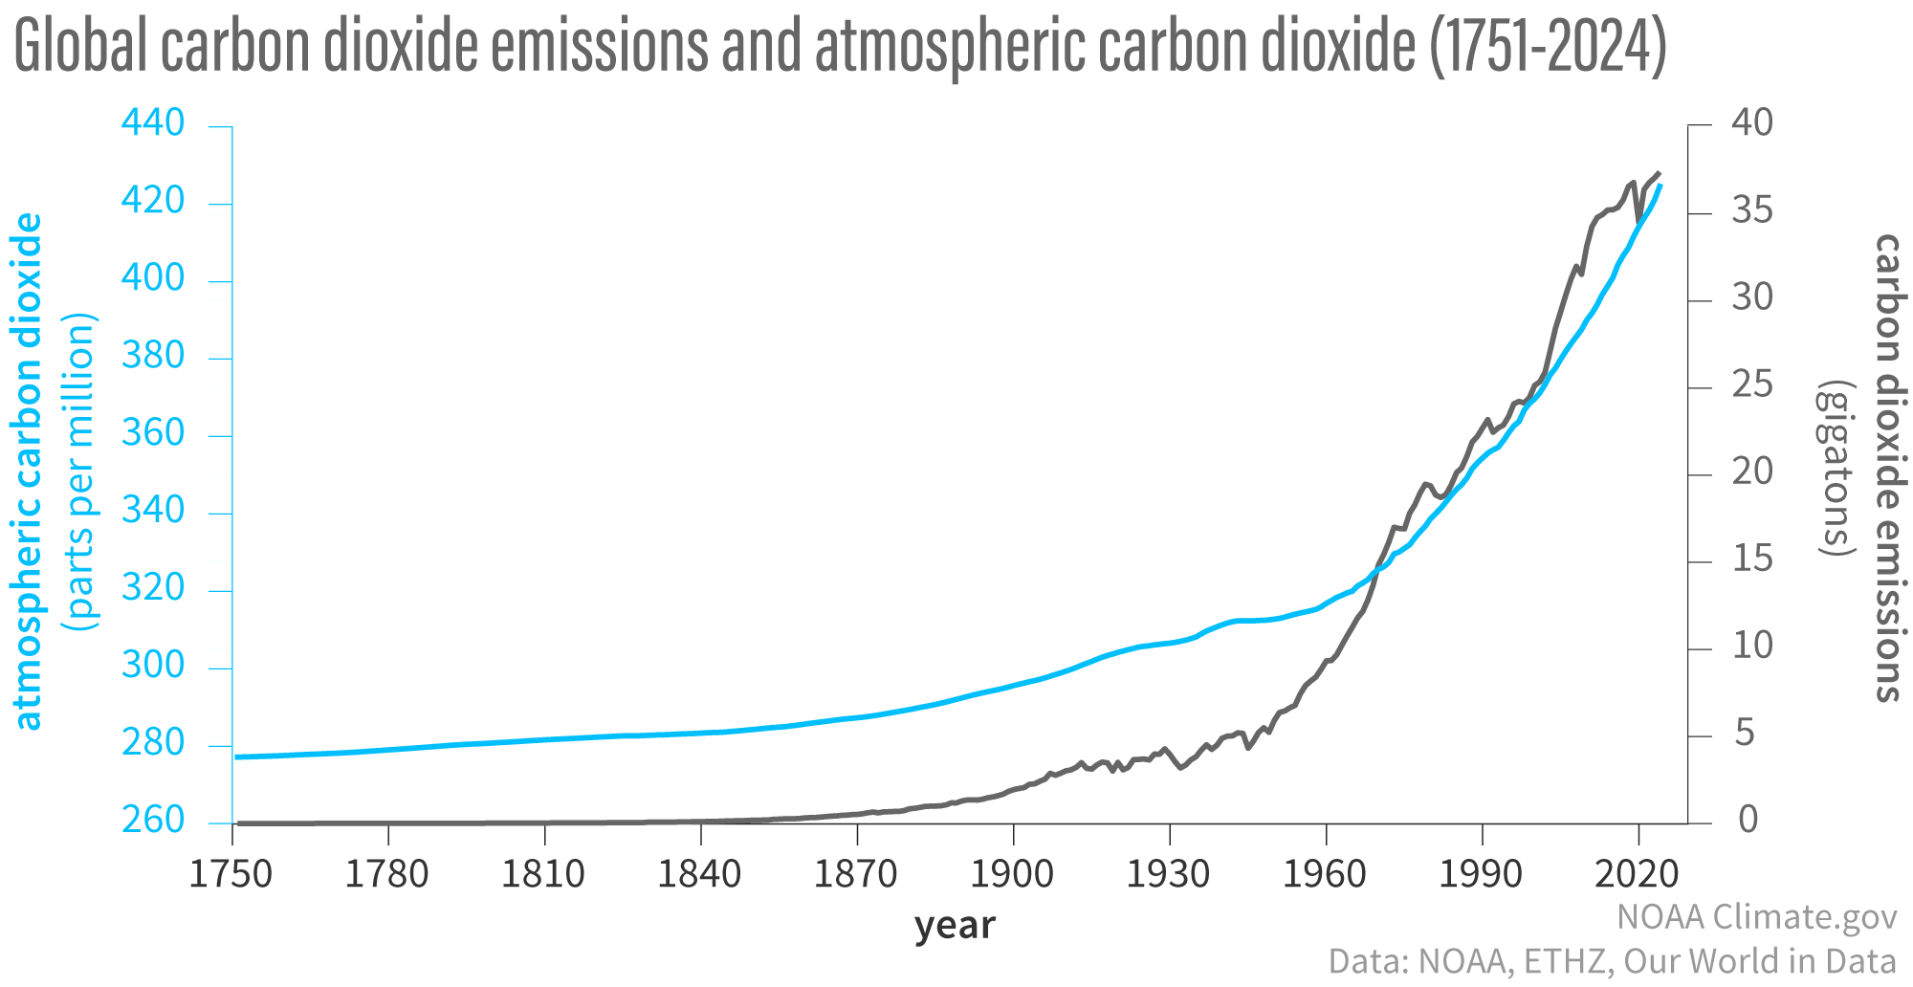
Figure 2: NOAA graph depicting Atmospheric CO₂ (blue line) compared to CO₂ emissions from burning fossil fuels (dark grey line) .

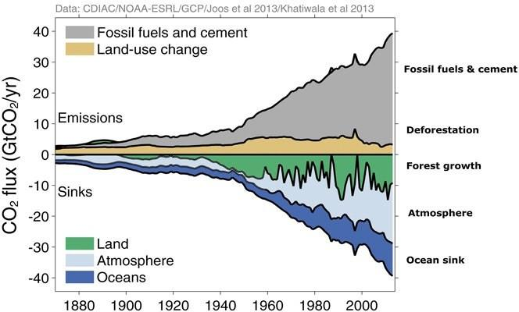
Figure 3: NOAA graph showing the breakdown of CO₂ emissions from burning fossil fuels and the making of cement as compared to carbon sinks (places such as forests, wetlands, and the atmosphere that utilize and “store” CO₂) .

Around one-quarter of the CO₂ in the atmosphere is absorbed by the ocean, so oceanic CO₂ concentrations have also been increasing over the past 100 years.

If students are having trouble understanding how and why carbon moves throughout the Earth, we recommend playing the Carbon Cycle game, which takes students through the carbon cycle as carbon molecules.

Ocean Chemistry & pH

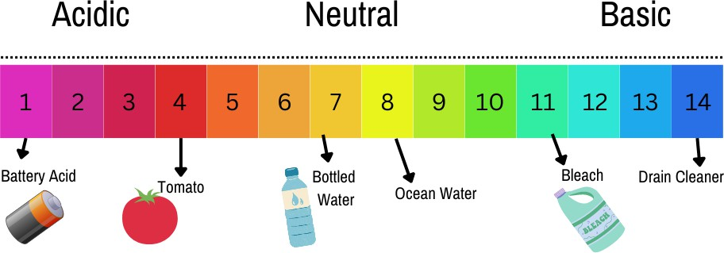
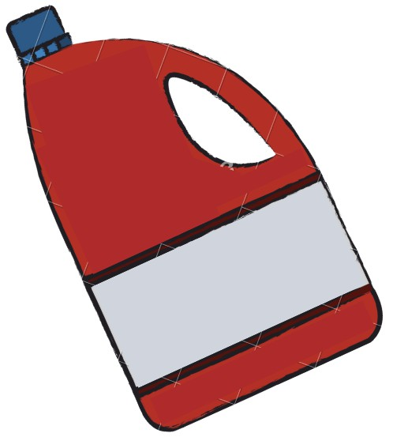
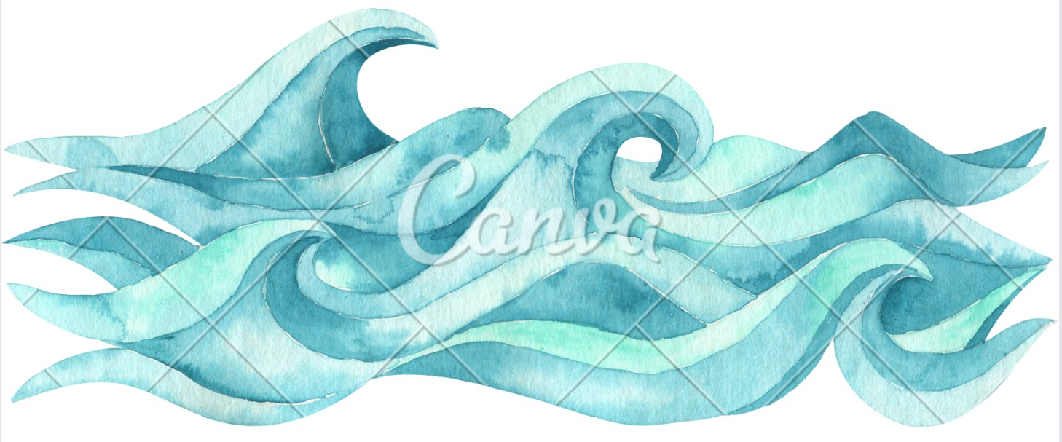

Figure 4: the pH scale. Lower numbers equate to more acidic qualities and higher numbers equate to more basic qualities

How does the increase in CO₂ concentrations affect the ocean?

The pH of a substance depends on the number of hydrogen ions present. The higher the number of hydrogen ions, the higher the “acidity”, and the lower the pH of a substance is. Substances with a high pH and a low number of hydrogen ions are called basic on the pH scale. For example, battery acid would have a pH of 0, whereas drain cleaner, which is very basic, would have a pH of 14. In chemistry, basics are called bases and are used to neutralize acids. Distilled water has a neutral pH of 7, whereas saltwater has a more basic pH of around 8. Prior to the Industrial Revolution, the pH of the open ocean was measured to be around 8.2 but is currently measured at 8.1. Although this looks like an insignificant change, it is actually a 25% increase in acidity from the preindustrial era to now, as pH is measured on a logarithmic scale.
When CO₂ is dissolved into the water, it reacts with water to form carbonic acid (H₂CO₃). H₂CO₃ then reacts with carbonate (CO₃²⁻) to form bicarbonate (HCO₃⁻). The hydrogen ions released by these reactions lower the pH of the water and cause ocean acidification.
As CO₂ levels in the atmosphere continue to increase, ocean absorption of CO₂ and thus ocean acidification continues to increase.

Coastal Acidification vs. Ocean Acidification

As discussed above in detail, increased amounts of CO₂ in the atmosphere cause a decrease in ocean pH in a process known as ocean acidification. Although a common misconception, the open ocean is not acidic but does continue to become more acidic with each passing decade. In open ocean waters, increased CO₂ is the primary driver of ocean acidification.

Coastal acidification has been used less commonly and refers more specifically to pH changes in coastal waters. In addition to the acidification caused by excess CO₂, local factors such as nutrient runoff, upwelling, and hypoxia can cause further acidification in coastal waters. Coastal acidification can encompass all of these coastal factors but occurs uniquely in each coastal area depending on the stressors there. Eutrophication in particular can cause additional coastal acidification. As excess algal blooms die, their decomposing tissue releases CO₂ into the water and increases acidity. Coastal areas that see large amounts of freshwater and sediment inputs, which are naturally more acidic, may also see increased acidity.

Besides acidification, other local stressors such as toxins, marine debris, overfishing, and shoreline changes can compound and create a unique set of problems for the individual organisms and ecosystems in each coastal and estuarine area. Fish already become stressed in low oxygen level environments and with rising temperatures, but the addition of acidification compounds these effects. Minimizing local stressors can help the organisms in a specific area be more resilient in the face of acidification.

Biological Impacts

One of the largest effects of ocean acidification is the decrease in calcium carbonate solubility. More CO₂ and a lower pH reduces the concentration of carbonate ions in ocean water. Carbonate is one of the ions that make up calcium carbonate, which is a mineral used by many marine plants and animals to build their shells and skeletons. Less carbonate means less calcium carbonate which makes it more difficult for these animals to build their shells. Unlike finfish that can move to less stressful environments, adult oysters are unable to move to areas with better water quality.

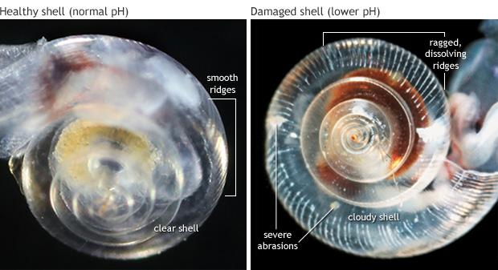
Figure 5: (left) A healthy ocean snail has a transparent shell with smoothly contoured ridges. (right) A shell exposed to more acidic, corrosive waters is cloudy, ragged, and pockmarked with ‘kinks’ and weak spots. Photos courtesy Nina Bednarsek, NOAA PMEL.Climate change: atmospheric carbon dioxide
A growing number of studies have demonstrated the effects of ocean acidification on marine organisms. These include the reduced survival of larval marine species, impaired development of invertebrates, and excessive CO₂ levels in the blood of some fish that can greatly reduce their growth and fertility. Similar fish do not always react similarly to acidification, so it can be hard for researchers to make assumptions about groups of fish species. Based on research so far, it seems freshly hatched fish are most vulnerable to acidification while most adult and juvenile fish are likely to survive.

Some species, like algae and seagrass, take in CO₂ as part of photosynthesis and are more likely to thrive in high CO₂ conditions. Research is being conducted to determine if seagrass can help to mitigate coastal acidification with the potential for the use of seagrass to lessen acidic conditions, but research is still preliminary.

Key Terms

Coastal Acidification - all of the processes that lead to acidification in coastal and estuary areas including, but certainly not limited to ocean acidification

Ocean acidification - the process of the ocean becoming more acidic due to absorption of increased CO₂ emissions

pH - stands for the power of hydrogen. It’s the measure of hydrogen ions in water. More hydrogen ions correlate to a lower pH or more acidic conditions. pH = -log[H+]

Upwelling - when cold waters from the deeper parts of the ocean rise and replace surface waters. Deep waters often bring with them a high nutrient level and low pH

6. Additional Resources

The Mid-Atlantic Coastal Acidification Network has many resources and news stories related to coastal acidification in the Mid-Atlantic region
Virginia Sea Grant site talking about the biological impacts of acidification in the Chesapeake Bay
The EPA’s guide to understanding ocean acidification
What is Ocean Acidification - NOAA Ocean Acidification Program

