Section III. Ocean Acidification Chemistry
There are 2 activities in this section. One will explore how burning fossil fuels (combustion) causes oceans to acidify. The other activity will go more in-depth about how this will affect marine organisms that utilize calcium carbonate.

In the previous section, students learned how carbon forms different bonds and cycles through different sinks. One of the ways that carbon moves from one sink to another is when humans burn fossil fuels. Burning coal, oil, and gas breaks the bonds that hold carbon atoms together inside those fuels, and carbon is released into the atmosphere. The ocean absorbs about a quarter of the CO₂ we release into the atmosphere every year, so as atmospheric CO₂ levels increase, so do the levels in the ocean. Initially, many scientists focused on the benefits of the ocean as a carbon sink as it is removing this greenhouse gas from the atmosphere. However, decades of ocean observations now show that there is also a downside: the CO₂ absorbed by the ocean is changing the chemistry of seawater.

As the ocean absorbs increasing amounts of CO₂ from the atmosphere, chemical reactions take place that decrease the pH of the ocean. This lowering of pH makes ocean water more acidic. The ocean’s pH has lowered by 0.1 pH units since the Industrial Revolution. This may not seem like much, but pH is measured on a logarithmic scale, which means a 0.1 difference in pH indicates the ocean has become 30% more acidic. With CO₂ continuing to sink into the ocean at extreme rates, scientists predict that the ocean could become 150% more acidic by 2100.

Standards:
NGSS: MS-PS1-2, MS-LS2-1, MS-ESS3-5, HS-PS1-2, HS-LS2-6, HS-ESS2-2, HS-ESS3-5, HS-ESS3-6
VA State Science Standards: PS.1, PS.3, CH.1, CH.5, ES.1, ES.10, ES.11

Combustion and Ocean Acidification Experiment Topic: Chemistry, pH, Ocean Acidification Objective: In this lesson, students will be able to:
- Show students how CO₂ is created by combustion in our atmosphere, and then diffuses into the ocean, changing the pH and making the ocean more acidic.
- Use the scientific method to hypothesize, test, record, and make conclusions about the effects of decreasing acidity on marine organisms that use calcium carbonate to build their skeletal structures.

Materials:
  - Dilute Bromothymol blue (BTB)
*Note that BTB is a chemical and can be harmful if used improperly
  - Two test tubes with stoppers. Make sure to use tubes made of glass or a plastic that will not melt when held up to a flame
  - Candle (preferably non-scented tea lights)
  - Match or some other device to light the candle

Set up:
Students will perform a simple lab to observe how humans create CO₂ by combustion and how easily CO₂ is absorbed by water. In this activity, the burning (or combustion) of the candle represents the burning of fossil fuels, the air in the combustion test tube represents the Earth’s atmosphere, and the water represents the ocean. The pouring of water into the combustion test tube represents how wind, waves, and ocean currents physically move seawater, which allows CO2 to dissolve into it. The Bromothymol blue (BTB) helps students to better visualize the change. Please remind students this lab is a visualization to help them better understand ocean acidification; this lab creates super-fast reactions in relation to time and on a much, much, much smaller scale than in Earth’s actual atmosphere and ocean.

Combustion is the process of burning organic material in the presence of oxygen to produce heat energy, CO₂, and water. Examples of some organic materials include wood, paper, and fossil fuels (natural gas, oil, or coal). These organic materials, and other organic materials that combust, all consist of carbon and hydrogen. They may also include oxygen and some other elements. When the organic material is burned in a complete reaction, the carbon is released in the form of CO₂. About 25-40% of the CO₂ from the burning of fuels is dissolved in water and will affect the pH of the water, which is creating havoc in oceans.

Activity:

Briefly introduce your students to the topic of combustion and how this creates CO₂. Then have students research ocean acidification and how an excess of CO₂ in our atmosphere from combustion or the burning of fossil fuels (coal, gas, oil), is being dissolved into the ocean and changing the ocean’s pH. Based on their research, have them make a hypothesis on what will happen during the experiment.

Bromothymol blue (BTB) indicates changes in pH and the presence of CO₂. This activity uses BTB to indicate if we have captured CO₂ gas from our combustion experiment and how the CO₂ gas changed the pH of the water.

- Label your two test tubes “air” and “combustion.”
- Pour approximately 5mL of dilute BTB into the test tube labeled “air.” Then cap the test tube and shake it for approximately 10 seconds. Observe the BTB solution. Do you notice any color change?
- Set the “air” test tube aside and record your observations in your lab notebook.
- Light the candle
- Uncap the test tube labeled “combustion” and hold it upside down above the flame for 10 seconds.
- While the test tube is still upside down, cap it.
- Once capped, the “combustion” test tube may be inverted. Then uncap the BTB solution.
- Carefully uncap the “combustion” test tube and replace the cap with your thumb. Roll your thumb to create a very small opening and quickly pour approximately 5mL of dilute BTB solution into the test tube.
- Recap the “combustion” test tube and shake for approximately 10 seconds.
- Compare the BTB in the test tube labeled “air” to the BTB in the test tube labeled “combustion.” Record your observations in your lab notebook.

Follow-up Questions:
Please answer these questions in your lab book:
- Which gas was captured in the “combustion” test tube?
- Why did combustion change the water’s pH?
- What does a change from blue to yellow in the bromothymol blue and water solution indicate in relation to the pH?
- List four (4) activities that humans do that combust fossil fuels.
- How can you relate this experiment to CO₂ in our atmosphere and ocean acidification? What does the test tube represent? What do the air and water symbolize? What does the burning of the candle represent? How does pouring the water into the combustion test tube relate to ocean currents and waves?
- How might humans reduce the amount of CO₂ that enters the ocean?

Printouts/ worksheets:
A lab worksheet for students can be found here.

Credits: This activity was adapted from The Basics of Ocean Acidification lesson from the NJ Sea Grant Consortium.
Acid in the Ocean: Not a Shell (Building) Game

Topic: Impacts of increased ocean acidity on marine animals
Objective: In this lesson, students will explore how excess CO2 in our atmosphere diffuses into the ocean, changes the chemistry of seawater, and how that hinders the ability of some marine organisms to build their skeletal structures by constructing simple a model out of Legos.

Background: We know that the pH in the ocean is decreasing and becoming more acidic as the ocean absorbs increasingly higher levels of CO2 from the atmosphere. Water changes pH as it gains or loses hydrogen ions (H+). As CO2 is absorbed by the ocean, it creates carbonic acid (H₂CO₃). Carbonic acid further breaks down and forms bicarbonate ions (HCO3) and hydrogen (H+) ions. An increase in hydrogen (H+) ions increases the ocean’s acidity, decreasing pH.
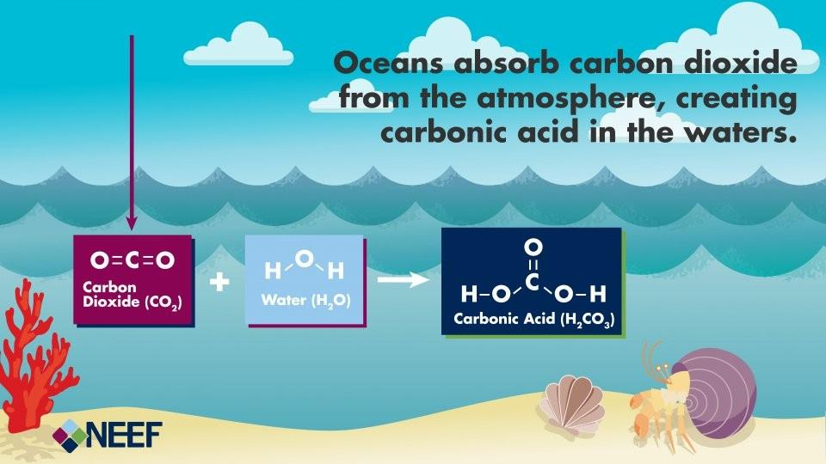
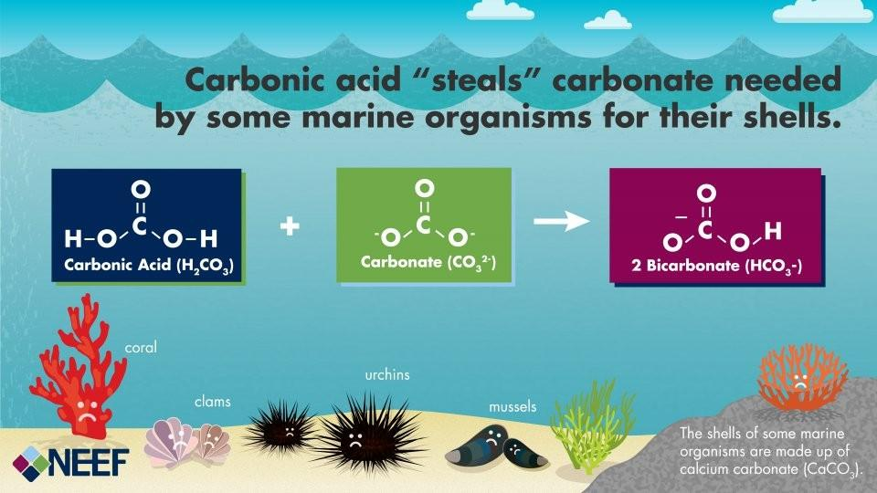
Understanding the Science of Ocean and Coastal Acidification | US EPA

Hydrogen ions (H+) also combine with carbonate ions (CO₃) dissolved in seawater to form bicarbonate ions (HCO₃) that are not useful to organisms. Carbonate ions bond eagerly with hydrogen ions in water; carbonate will even leave calcium behind to bond with hydrogen ions. More hydrogen ions in the ocean interfere with shell or skeleton formation because they reduce the amount of carbonate available for organisms that need calcium and carbonate to bond to grow their shells and skeletons.

Materials
- 3 colors of Legos (12 yellow, 12 blue, 8 red per bag)
- Use Duplo Legos if you want bigger blocks
- Small opaque reusable bags (one for each small group)
- A stopwatch or timer
- Student worksheets

Setup:
To set the stage for your students, explain that in the ocean many organisms build shells or skeletons made up of calcium carbonate which is available in seawater. Ask students if they can name some animals that have shells. If possible, show the students a few seashells (clams, scallops, snails) and/or pieces of coral or pictures of seashells and/or corals. Ask students to brainstorm how these animals are important to oceans and to humans. Be sure that students know that these organisms are an important food source for other ocean organisms and also can provide a source of food and income for humans.
Explain that a decrease in organisms in the ocean impacts food webs, decreases biodiversity, reduces the health of the ocean, and can even result in the loss of jobs and income for people. Coral reefs are a great example since they are simultaneously important habitats and essential to ocean health. Explain how these organisms take in calcium and carbonate dissolved in seawater and combine them to make calcium carbonate, which forms their shell and/or skeleton. In a healthy ocean, organisms can form and grow their shell fairly easily, extracting all the calcium and carbonate they need from seawater. However, the amount of carbonate in the ocean is decreasing because humans are releasing excess CO₂ into our atmosphere.

Activity

To further understand the chemistry of ocean acidification and its effect on organisms that need calcium carbonate to build shells and skeletons, students will play a game using Lego blocks (or other interlocking blocks). Each different color Lego block used in the game represents chemicals found in the ocean which support the growth of animals that build shells and skeletons. The game goes through different scenarios which will demonstrate to players the impact ocean acidification will have on many species of animals in the ocean.

Students will play three (3) rounds:
- The first round is based on pre-industrial ocean water conditions
- The second is based on current seawater conditions,
- The third is based on future predicted ocean water conditions.

In this activity each color Lego is a different ion or bond. You can assign any Lego color to a chemical as long as they are consistent across groups. For the purposes of this set of instructions, we will use the following colors:

Lego | Ion/ molecule
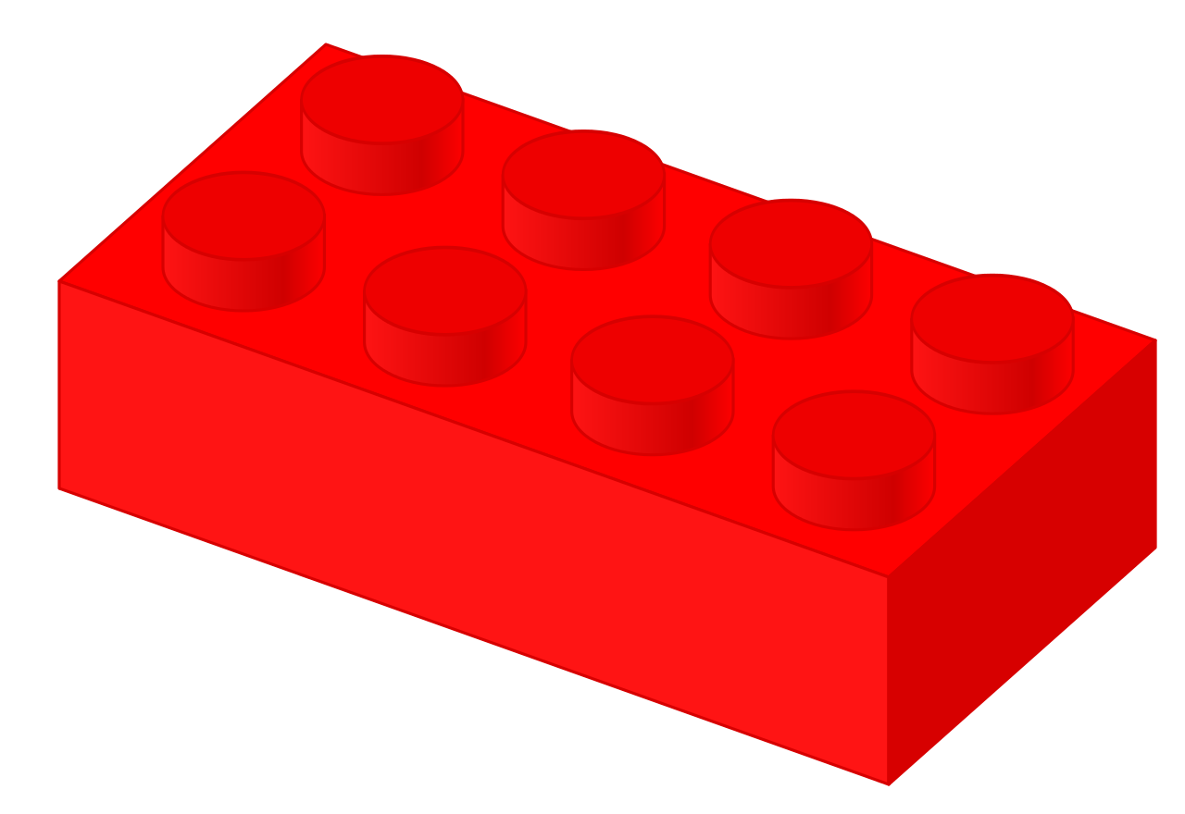 | H+ (Hydrogen)  *amount determines pH of seawater
 | CO₃ (Carbonate)
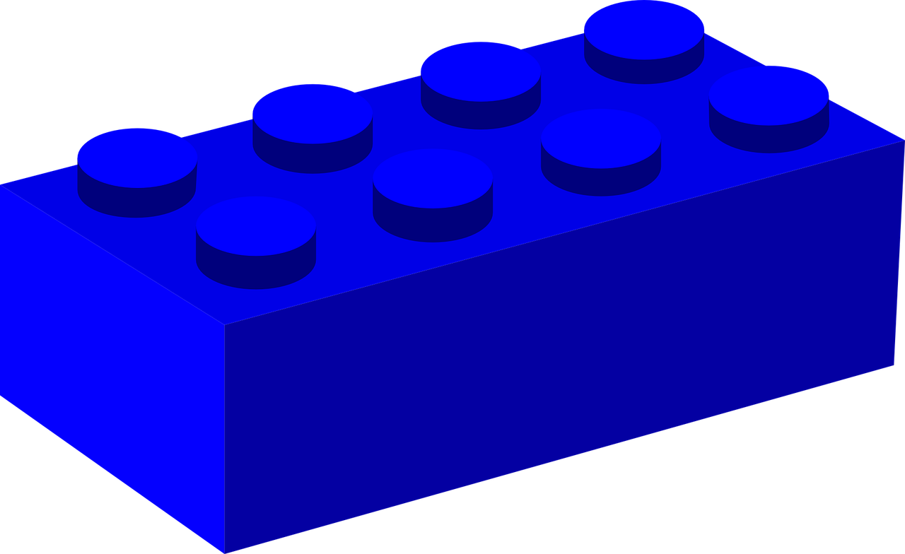 | Ca+ (Calcium)

CaCO₃ (Calcium Carbonate)
-
HCO₃ (Bicarbonate)

*Access the student worksheet here

Basic rules:
  - The more hydrogen ions are present in the water, the more acidic ocean water becomes.
  - The carbonate ions (yellow Legos) are very attracted to and bond eagerly with the hydrogen ions (red Legos)
  - The carbonate ions (yellow Legos) will not bond with calcium (blue Legos) when there are hydrogen ions (red Legos) available to bond with
  - When the carbonate ions (yellow legos) connect or bond with hydrogen ions (red Legos) they form bicarbonate, which is not useful for many forms of sea life.
  - The blue Legos (dissolved calcium ions) are left on their own.
While playing the game, students will see what happens when excess hydrogen enters the ocean (ocean acidification).

Students will have one minute to reach into the bag and take just one Lego out at a time. Players may not look into the bag to choose Legos. As Legos are taken out, players must combine yellow Legos, representing carbonate ions (Co₃), to the blue Legos representing calcium (Ca+), as fast as possible to form a calcium carbonate which is used by organisms to build shells or skeleton. If a red (H+) Lego and yellow (Co₃) Lego are chosen, you must combine the red (H+) and yellow (Co₃) to form bicarbonates (HCo₃). If possible, students must connect the Legos to form calcium carbonates or bicarbonates before choosing another Lego out of the bag. If two of the same colors are chosen, players must set them aside and wait to connect them to the correct color on the next grab.
Example- If a player pulls out 2 yellow Legos but not any blue or red blocks, that player must set the yellow blocks aside and wait until blue or red blocks are grabbed.

As yellow and blue Legos are connected, each set should be connected together into one large structure, just as an animal building a shell would do. When a red Lego, representing a hydrogen ion, is pulled out of the bag, it must be connected to any yellow carbonate Lego that is not already paired with blue calcium Lego. This forms bicarbonate that is not useful for shell or skeleton building, and players must set it aside. Carbonates are much more strongly attracted to
hydrogen ions. Therefore a yellow carbonate block must connect to a red hydrogen block if a red block is available. Players are not to have any red blocks unconnected unless a yellow block has not yet been pulled out of the bag. Blue calcium blocks never connect to red hydrogen blocks.
After one (1) minute, players should count how many blue and yellow Lego pairs they were able to connect, and have the students record their results. Be sure players only count the pairs of yellow and blue.

Round One
- Disconnect and place 12 yellow, 12 blue, and 2 red Legos in a bag. The amount of red Legos (representing hydrogen ions) in this round reflects the amount of hydrogen found in seawater before industrial times.
- Set the timer for 1 minute.
- Have players reach into the bag and grab one (1) Lego at a time. They may not look in the bag to choose their blocks. If a blue and a yellow block are picked, they need to be connected to represent calcium carbonate.
Note: If a red and a yellow block are picked, those need to be connected to represent bicarbonate. Red and blue blocks never connect and neither do two (2) blocks of the same color.
- If blocks are picked out of the bag that cannot connect, such as two blocks of the same color, or red and blue, players must set them aside until another red, blue, or yellow block is picked out of the bag that can connect together.
Note: Anytime a red block is pulled out of the bag, it must be connected to a yellow block to form bicarbonate. A blue block can be connected to a yellow block only when no red blocks have been selected out of the bag. All sets of yellow and blue Legos, representing calcium carbonate, should be connected to represent the formation of one animal shell, such as a shell, or a coral. Any red and yellow blocks that were connected represent bicarbonates, and cannot be used by an animal.
- Put aside any unconnected blue blocks.
- Students should quantify how many pairs of calcium carbonate they formed and record the number. This represents the growth in their animal.
- After completing this round, students should be directed to disconnect all the blocks and place them back into the bag to prepare for Round 2.

Round Two
- Place 12 yellow, 12 blue, and 3 red Legos in a bag. The amount of red Legos represent the amount of hydrogen found in seawater in 2018. This represents the increase in ocean acidity since pre-industrial times. This increase in acidity is caused by an increase in carbon dioxide absorbed by the ocean from the burning of fossil fuels (coal, oil, gas.) When the ocean absorbs excess carbon dioxide chemical changes increase the amount of hydrogen in the ocean, increasing ocean acidity.
- Repeat the game following the steps listed above. Students should count and record the pairs of yellow and blue blocks, or calcium carbonate they formed and compare results to their results from the first round. Students might see a small difference in the amount of calcium carbonate formed. In today’s ocean, some sea animals do have a slightly more difficult time finding carbonate to form with calcium but most species are able to still do so.
- After completing this round, students should be directed to disconnect all the blocks and place them back into the bag to prepare for Round 3.

Round Three
- With a continued rise of carbon dioxide released in the atmosphere, it is predicted that the ocean will become nearly 150% more acidic by the end of the century. This will cause more hydrogen to be released into the ocean. For round three, keep 12 blue and 12 yellow Legos. Place a total of 6 red Legos in the bag.
- Again, time students for 1 minute. Remember, yellow carbonate blocks are much more attracted to the hydrogen red blocks; therefore red blocks always connect over blue blocks! If players have a free yellow block and then choose a red and blue block, the red block must be connected to the yellow block, and not the blue calcium block. Players may set the blue block aside until the next two blocks are grabbed out of the bag.
- Remember to have students record their data.

The End of the Game
Have students look at each chart they completed from the three rounds of play and compare the results. As a class or group, share and compare results. Students should notice a small difference between rounds 1 and 2, and a larger difference between rounds 1 and 3 and 2 and 3. Review the chemistry and have students explain how excess carbon dioxide released in our atmosphere is the root cause of ocean acidification.

Credits: This activity was adapted from The Basics of Ocean Acidification lessons from the NJ Sea Grant Consortium.

Handouts: Student worksheet for the small groups can be found here

