VISUALIZING OCEAN & COASTAL ACIDIFICATION LOCALLY

https://sites.google.com/view/vocalmidatlantic/home

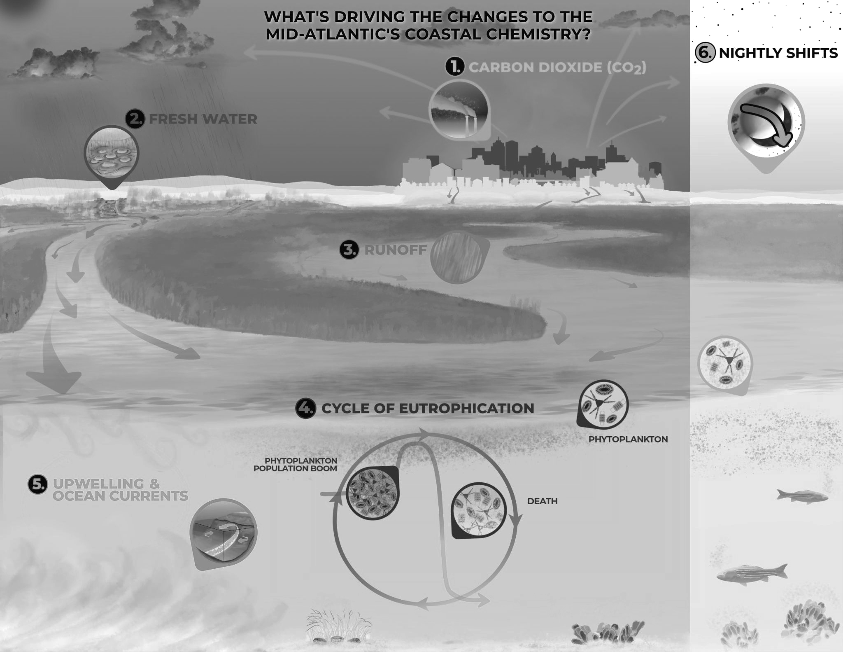
Bacteria, bad weather, fertilizer, and shellfish have something big in common: they all influence the acidity of the Mid-Atlantic’s coastal waters. Carbon dioxide is a major part of the problem, but factors like local rivers and even the mud in marshes are intensifying coastal acidification.

1. CO2
The ocean absorbs a quarter of the carbon dioxide (CO2) we produce, leading to complex chemical reactions, including the formation of carbonic acid (the same corrosive chemical that makes soda fizzy) and the release of hydrogen ions, the amount of which dictates a solution’s pH. The more hydrogen ions, the more acidic the water, and the lower the pH value.
Some hydrogen ions go on to bond with and remove carbonate ions, which are a vital ingredient in the recipe to build shells and hard structures for scallops and mollusks. As a result, ocean and coastal acidification can lead to too few carbonate ions and too much carbonic acid that can dissolve shells or make them difficult to build.

2. Freshwater inputs
The Mid-Atlantic region has many large rivers that flow into coastal areas like Delaware Bay, Chesapeake Bay, and Long Island Sound. Fresh water impacts coastal chemistry because it can’t maintain a stable pH when acids or bases are present. Rivers tend to be slightly more acidic than seawater and recent record-breaking rainfall is contributing to flooding and lower coastal pH. However, not all rivers are acidic all the time; if a river passes over calcium-rich rocks like limestone, the water's pH rises and may actually lessen coastal acidification.

3. Runoff
As freshwater streams and rivers travel through land, they pick up and carry contaminants downstream like pesticides, excess nutrient-rich fertilizer, food waste, and sewage; when the rivers eventually dump into coastal waters, the nutrients cause naturally-occurring algae populations to spike, a process called “eutrophication.” (See 4.) Reducing runoff may help ease acidic conditions on the coast.

4. Cycle of Eutrophication
Like terrestrial plants, algae and phytoplankton grow by taking in CO2, sunlight, and nutrients, and they produce oxygen as a byproduct.
If more nutrients are added, phytoplankton grow faster, using up additional CO2 and raising the pH of the water, especially at the sunlight-rich surface.
When the algae's growth outpaces animals’ ability to eat it, the excess dies and sinks to the bottom, where it becomes food for decomposing bacteria. As they break down the algae, the bacteria release CO2 and use up oxygen, worsening coastal acidification and creating hypoxic, or low-oxygen bottom water. This low-pH/low oxygen pattern is repeated seasonally, with a peak in summer when sunlight is most plentiful.

5. Upwelling
Oceanic waters can also contribute to coastal acidification. Deep ocean water is cut off from the surface where plants produce oxygen and CO₂ is absorbed. During the spring and summer, deep ocean water enters coastal areas through a process called “upwelling.” Low oxygen, high-CO2 upwelling water mixes with coastal water, contributing to variations in coastal acidification conditions.

6. Nightly shifts
Coastal acidification is influenced by growth and decomposition of algae (see Step 4), which means pH varies from day to night.
Once the sun sets, algae's CO₂ uptake, growth, and oxygen production slow, while animals and bacteria continue to generate CO₂, causing pH to fall.
Water has less oxygen, lower pH and fewer carbonate ions with which animals can construct their shells. It is possible for nightly conditions to become so extreme that they corrode shells, especially those of younger, smaller animals.

