Name____________________________________ Date______ Class____
Coastal Acidification Data Analysis
Introduction
The ocean plays a critical role in regulating Earth's climate by absorbing carbon dioxide (CO₂) from the atmosphere. However, as atmospheric CO₂ levels increase due to human activities, the ocean absorbs more CO₂, which can lead to ocean acidification. This worksheet will explore factors that influence ocean acidity and analyze real-world data on seasonal pH changes in coastal waters.
Learning Objectives
- Identify factors that can affect ocean acidity.
- Analyze data to observe seasonal trends in pH.
- Explain how seasonal changes in factors like upwelling and biological activity can influence pH levels.
Factors Affecting Ocean Acidity
- CO₂ Absorption: Ocean surface waters absorb CO₂ from the atmosphere. CO₂ reacts with water to form carbonic acid.
- Upwelling: Upwelling events bring deep, cold, and nutrient-rich ocean water to the surface. Upwelled water often has lower pH due to its natural source (from decomposition of organic matter in deep ocean) and the presence of dissolved CO₂.
- Freshwater Inputs: Freshwater from rivers and streams can be more acidic than ocean water, especially if it has traveled through acidic soils or rocks. Additionally, freshwater inputs can decrease salinity, which can indirectly affect ocean acidification processes.
- Biological Removal of CO₂: Marine plants and phytoplankton consume CO₂ for photosynthesis.
- Eutrophication: Excess nutrients from fertilizers, sewage, or other sources can stimulate excessive algal growth (blooms). When these algae die and decompose, they consume oxygen and release CO₂.

Part 1: Applying prior knowledge
- Recall that CO₂ in water will decrease the pH of the water, increasing its acidity. Which factors listed above could increase the acidity of water? Which will decrease the acidity?

- Consider the factors that influence ocean acidity. Which of these factors remain relatively stable throughout the year? Which factors are subject to change? Explain your reasoning.

Part 2: Data Analysis
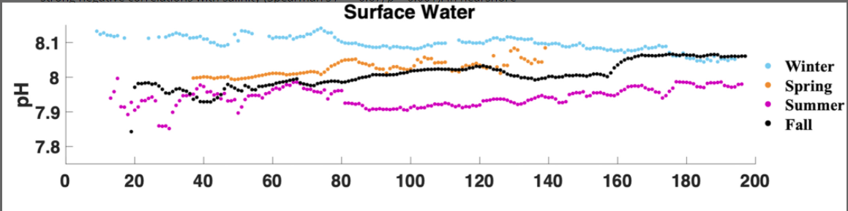

- What variable is measured on the y-axis, and what are the units? What variable is measured on the x-axis and what are the units?

- What range of pH do you see on the graph?

- What trends in pH can you observe about the seasons or about distance from shore?

- What season typically has the lowest pH? Why might this be?

- Which season typically has the highest pH? Why might this be?

- What other trends do you notice in the graph? What ideas do you have to explain them?

Evaluate:
- How do ocean acidification and coastal acidification differ? Why is it worthwhile to make this distinction?

- Predict the potential impacts of coastal acidification on marine ecosystems.

Graph and data was taken from “Autonomous Observation of Seasonal Carbonate Chemistry Dynamics in the Mid-Atlantic Bight ” (link and citation below). Thank you to Grace Saba for help with this activity.

Wright-Fairbanks, E. K., Miles, T. N., Cai, W.-J., Chen, B., Saba, G. K. (2020). Autonomous observation of seasonal carbonate chemistry dynamics in the Mid-Atlantic Bight. Journal of Geophysical Research: Oceans, 125, e2020JC016505. https://doi.org/10.1029/2020JC016505

