SUMMARY OF OCEAN ACIDIFICATION IMPACTS AMONG KEY TAXONOMIC GROUPS
 | CALCIFERS
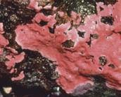Calcifying algae | Survival | Not tested or too few  studies | Early life stages are more susceptible to OA. Most susceptible of all calcifiers to OA. Reduction in abundance could affect coral establishment.
 | Calcification | Little or no effect
 | Growth | Not tested or too few  studies
 | Photosynthesis | Reduced -28%
 | Abundance | Reduced -80%
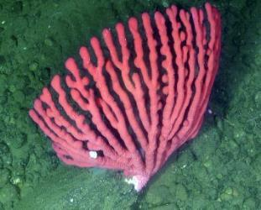Deep-sea corals | Survival | Little or no effect | Major effect on coral abundance due to reduction in settlement of coral larva.
 | Calcification | Reduced -32%
 | Growth | Little or no effect
 | Photosynthesis | Little or no effect
 | Abundance | Reduced -47%
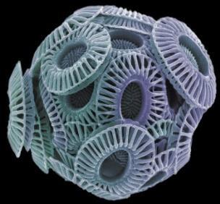Coccolithophores | Survival | Not tested or too few studies | Results vary between different species.
 | Calcification | Reduced -23% | Results vary between different species.
 | Growth | Little or no effect | Results vary between different species.
 | Photosynthesis | Positive effect for some species | Results vary between different species.
 | Abundance | Little or no effect | Results vary between different species.
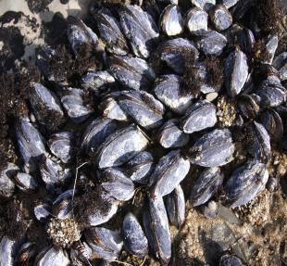Mollusks | Survival | Reduced -34% | Will have significant impact on pteropod growth and development, as well as early life stages of other shell- forming species.
 | Calcification | Reduced -40%
 | Growth | Reduced -17%
 | Development | Reduced -25%
 | Abundance | Little or no effect

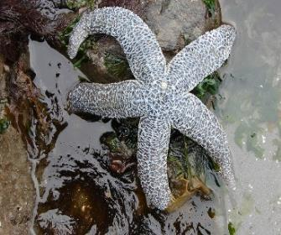  Echinoderms | Survival | Little or no  effect | Significant reduction in development of early life stages of sea urchins and other echinoderms.
 | Calcification | Little or no  effect
 | Growth | Reduced -10%
 | Development | Reduced -11%
 | Abundance | Not tested or  too few studies
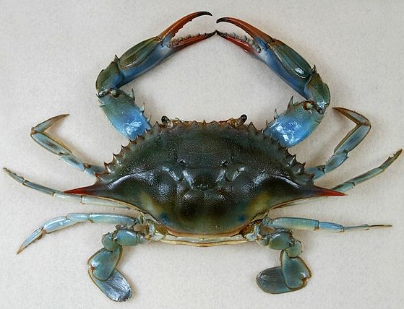  Crustaceans | Survival | Reduced | This group is relatively resistant to pH changes. However, research is beginning to show significant impacts on Blue crab, krill, and barnacle populations.
 | Reproduction | Reduced
 | Calcification | Not tested or  too few studies
 | Growth | Reduced
 | Development | Little or no  effect
 | Abundance | Little or no  effect
NON-CALCIFERS
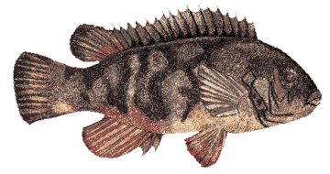  Fin Fish | Survival | Not tested or too  few studies | Affects olfactory senses of some fish species and their responses to chemical, signals for food, predators, schooling behaviors; loss  of habitat/food supply; larval survival.
 | Behavior | Not tested or too  few studies
 | Growth | Reduced for larva
 | Development | Not tested or too  few studies
 | Abundance | Not tested or too  few studies
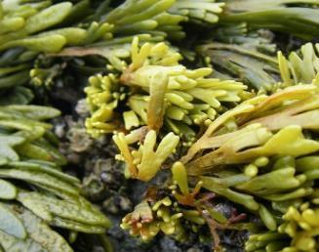  Fleshy algae | Survival | Not tested or too  few studies | Increased CO₂ increases fleshy algal growth (seaweeds).
 | Calcification | Not tested or too  few studies | Increased CO₂ increases fleshy algal growth (seaweeds).
 | Growth | Enhanced +22% | Increased CO₂ increases fleshy algal growth (seaweeds).
 | Photosynthesis | Little or no effect | Increased CO₂ increases fleshy algal growth (seaweeds).
 | Abundance | Little or no effect | Increased CO₂ increases fleshy algal growth (seaweeds).

 | 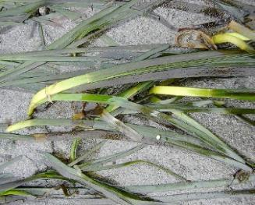  Seagrasses | Survival | Not tested or too  few studies | Seagrass growth may be increased with increased CO₂. Seagrasses may act as a habitat buffer from OA for shell-forming organisms.
 |  | Calcification | Not tested or too  few studies
 |  | Growth | Enhanced +22%
 |  | Photosynthesis | Little or no effect
 |  | Abundance | Not tested or too  few studies
 | 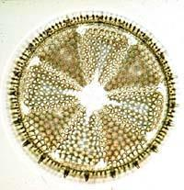  Diatoms | Survival | Not tested or too  few studies | Diatoms are generally positively affected by increased CO₂. Effects vary depending on the size of the diatoms.
 |  | Calcification | Not tested or too  few studies
 |  | Growth | Enhanced +17%
 |  | Photosynthesis | Enhanced +12%
 |  | Abundance | Little or no effect
Adapted from Kroeker et al 2013.

STUDENT WORKSHEET Name

Using the chart Summary of Effects of Ocean Acidification Among Key Taxonomic Groups and online research, answer each question in the corresponding box.

CALCIFERS
Calcifying algae At which life stages are calcifying algae most susceptible to OA?

What effect does OA have on the abundance of calcifying algae ?
Deep-sea corals How is deep sea coral abundance affected by OA?
Coccolithophores Coccolithophores are producers – how will their rates of photosynthesis change due to increased atmospheric CO₂?

Mollusks Name one species where OA will have a significant impact.

Which categories will be affected by OA for mollusk species?
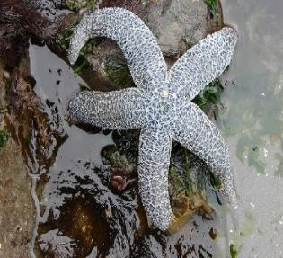 | Echinoderms What life stages are affected by OA in sea urchins?  Which categories will show a reduction due to OA?
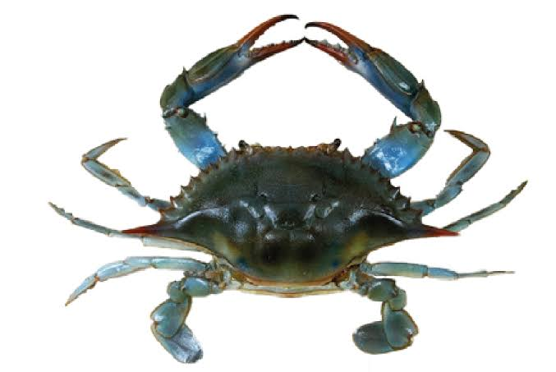 | Crustaceans Although crustaceans are relatively resistant to OA, what are some possible effects on crab populations?

NON-CALCIFERS
 | Finfish List three ways finfish species may be affected by OA
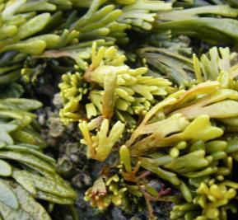 | Fleshy algae Why is growth of fleshy algae enhanced by OA?
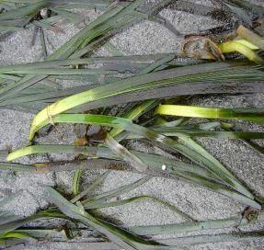 | Seagrasses How might enhanced growth of seagrasses benefit shell-forming marine organisms?
 | Diatoms Why will growth and photosynthesis of diatoms be enhanced by OA?
Summarize in one sentence how OA will negatively affect calcifying marine organisms.

