Directions for Sorting Activity
Shells serve as protective structures for both marine and terrestrial organisms. In marine ecosystems, organisms depend on calcium carbonate in sea water to make their shells and build structures, such as coral reefs and oyster beds. Oyster shells, coral skeletons, and the habitats they create can be impacted by changes in ocean pH due to increased carbon dioxide. Do you know which of these organisms uses calcium carbonate for shell and reef building and which do not?

Sort the images into two groups:
Calcifiers and Non-calcifiers
(Calcifiers are organisms that make their shell or part of their body using calcium carbonate from the seawater).

Record your answers in the following table:

CALCIFIERS | NON-CALCIFIERS

Images for Sorting Activity

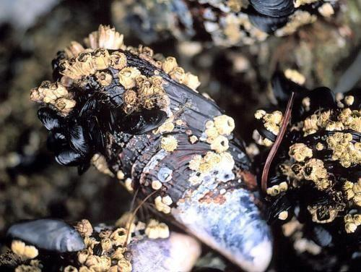
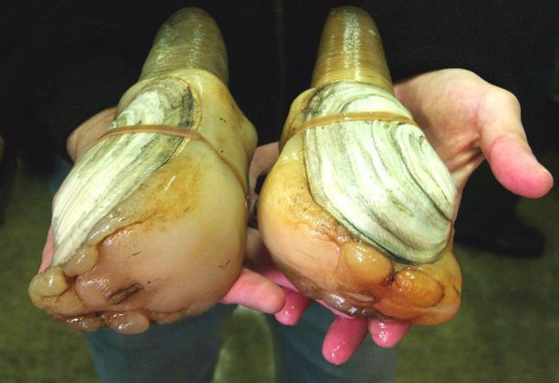
WA Dept. Fish and Wildlife USDA.gov

Blue Mussel Clams

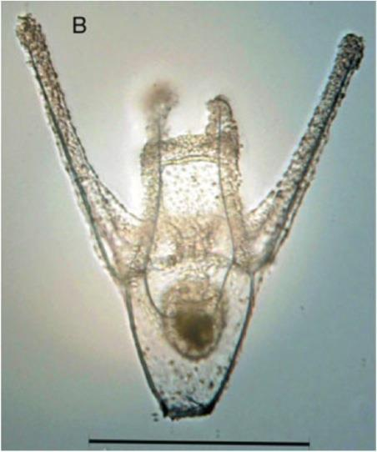
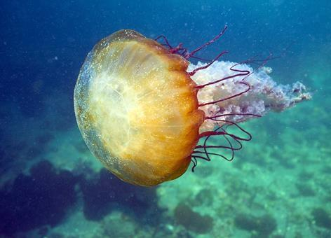
Source: O’Donell et al. (2010) NOAA

Urchin Larvae Brown Sea Nettle
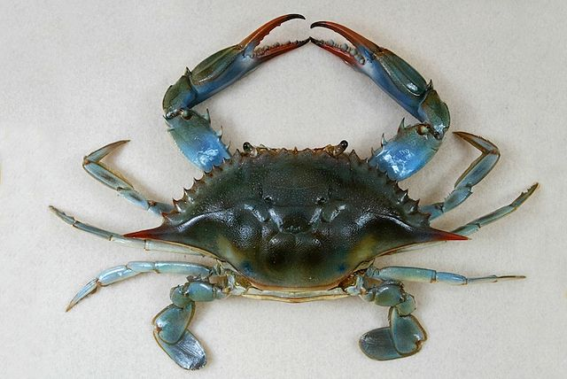
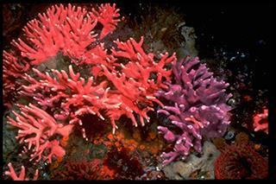
Cordell Expeditions

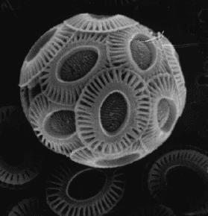
Blue Crab Hydrocoral

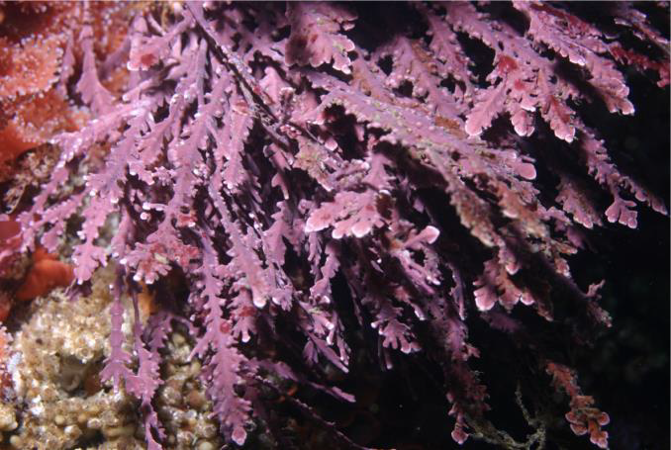
Greater Farallones NMS/NOAA

Coralline Algae

NOAA

Coccolithophores

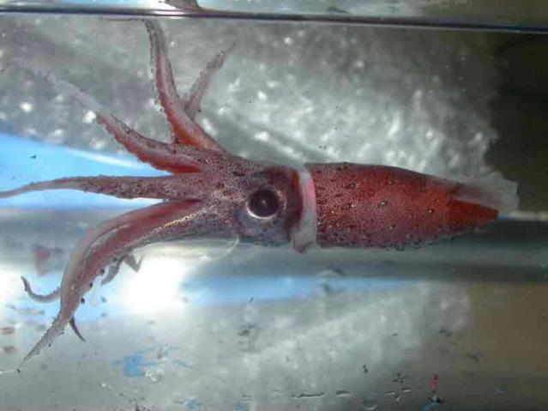

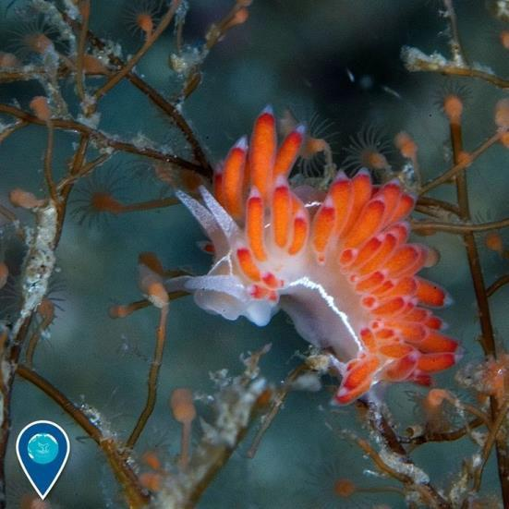
NOAA

Nudibranch (Sea slug)

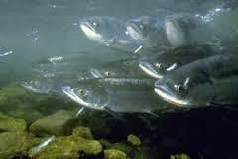
NOAA

Salmon
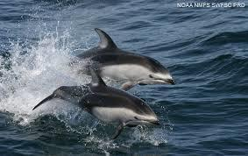
NMFS/NOAA

Squid

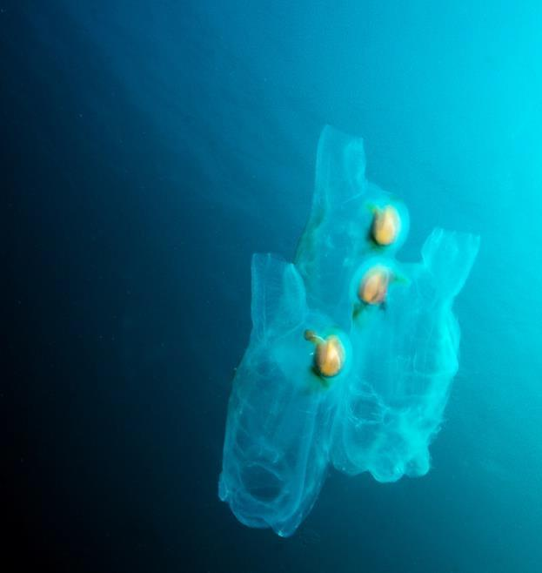
Pete Naylor / REEF

Pelagic Tunicate

