STUDENT WORKSHEET Name

Using the chart Summary of Effects of Ocean Acidification Among Key Taxonomic Groups and online research, answer each question in the corresponding box.

CALCIFERS
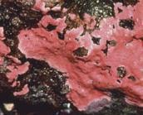 | Calcifying algae At which life stages are calcifying algae most susceptible to OA?  What effect does OA have on the abundance of calcifying algae ?
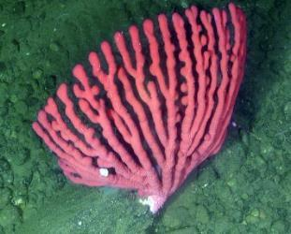 | Deep-sea corals How is deep sea coral abundance affected by OA?
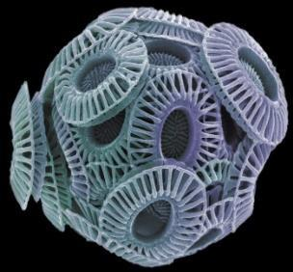 | Coccolithophores Coccolithophores are producers – how will their rates of photosynthesis change due to increased atmospheric CO₂?

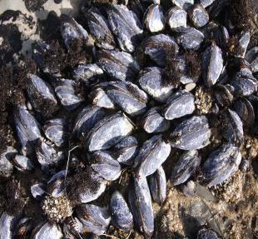 | Mollusks Name one species where OA will have a significant impact.  Which categories will be affected by OA for mollusk species?
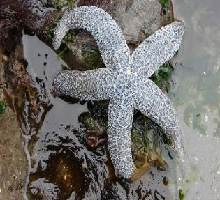 | Echinoderms What life stages are affected by OA in sea urchins?  Which categories will show a reduction due to OA?
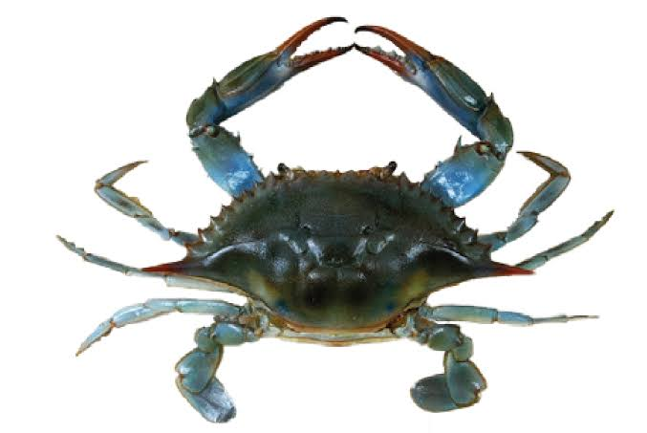 | Crustaceans Although crustaceans are relatively resistant to OA, what are some possible effects on crab populations?

NON-CALCIFERS
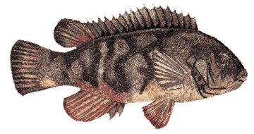 | Finfish List three ways finfish species may be affected by OA
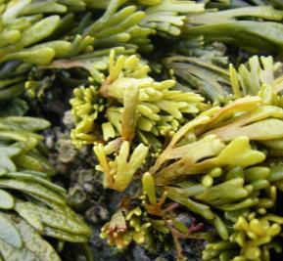 | Fleshy algae Why is growth of fleshy algae enhanced by OA?
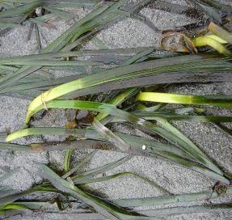 | Seagrasses How might enhanced growth of seagrasses benefit shell-forming marine organisms?
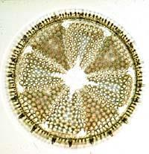 | Diatoms Why will growth and photosynthesis of diatoms be enhanced by OA?
Summarize in one sentence how OA will negatively affect calcifying marine organisms.

