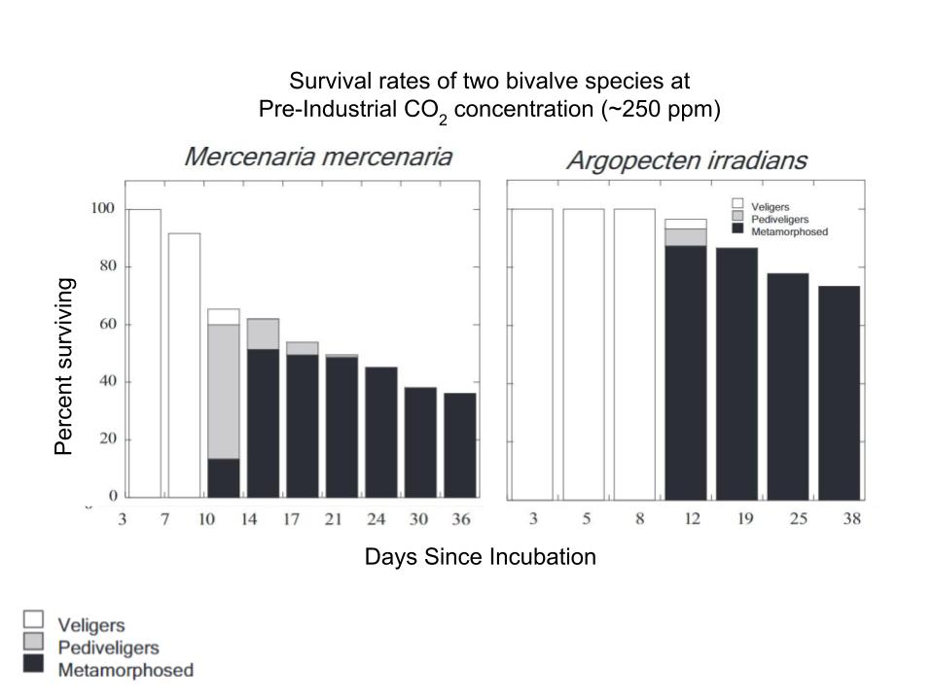
Getting comfortable with your data table:
- What is shown on the X-axis? ________days since incubation___________________________
- What is shown on the Y-axis? _________percent surviving______________________________
- Why are there two data tables on this page (how do they differ)? The graphs represent two different bivalve species and their survival rates at pre-industrial CO₂ concentrations (low CO₂)
Analysis:
- After 36 days, what percentage of Mercenaria mercenaria are still alive?_about 38%____
- After 38 days, what percentage of Argopecten irradians are still alive? ___about 74%__________
- How would you summarize the data from the tables in a single sentence?
At pre-industrial CO₂ concentrations, 38% of hard clams and 74% of scallops survive until metamorphosis
Make connections (answer after completing your other data table):
- How do the outcomes on this data table compare to the data tables on your other sheet (Pre-industrial versus present conditions)?
When this data is compared to Data Table 2, it shows that more hard clams and scallops survive until metamorphosis at pre-industrial CO₂ concentrations than they do at current CO₂ concentrations.

Getting comfortable with your data table:
- What is shown on the X-axis? ________days since incubation___________________________
- What is shown on the Y-axis? _________percent surviving______________________________
- Why are there two data tables on this page (how do they differ)? The graphs represent two different bivalve species and their survival rates at present-day CO₂ concentrations
Analysis:
- After 36 days, what percentage of Mercenaria mercenaria are still alive?__20%________________
- After 38 days, what percentage of Argopecten irradians are still alive? ____42%________________
- How would you summarize the data from the tables in a single sentence?
At current CO₂ concentrations, 20% of hard clams and 42% of scallops survive until metamorphosis
Make connections (answer after completing your other data table):
- How do the outcomes on this data table compare to the data in Table 1?
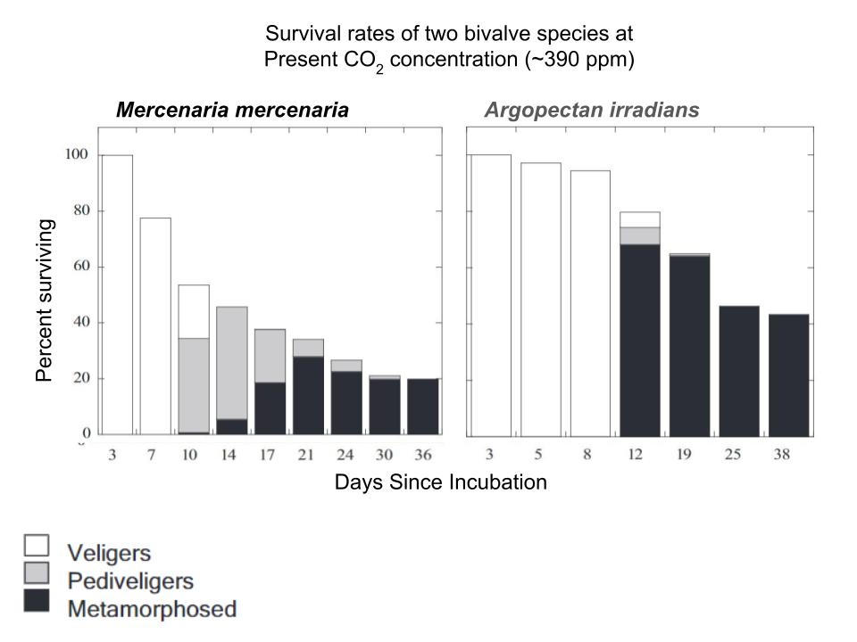
When this data is compared to Data Table 1, it shows that more hard clams and scallops survive until metamorphosis at pre-industrial CO₂ concentrations than they do at current CO₂ concentrations.
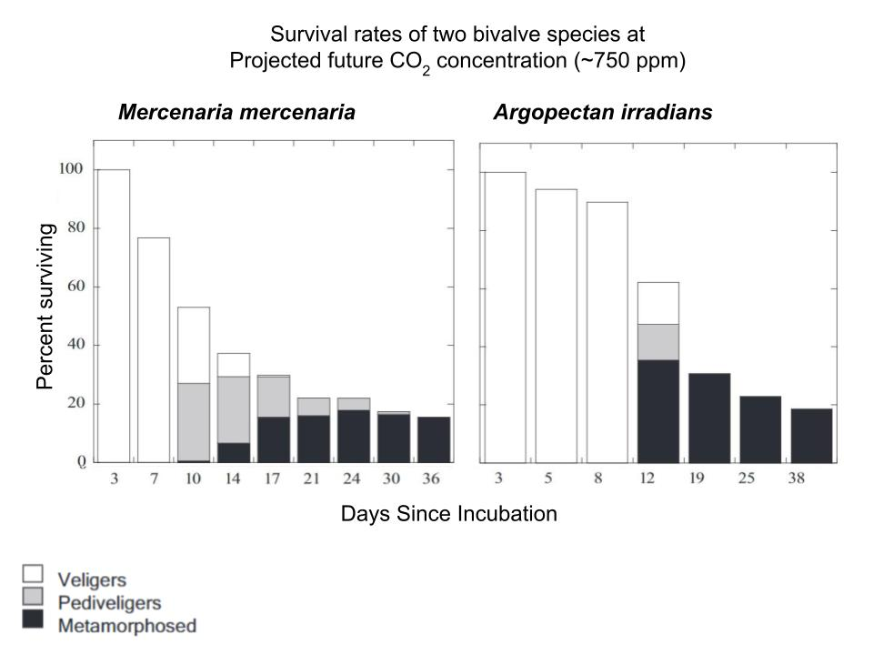

Getting comfortable with your data table:
- What is shown on the X-axis? ________days since incubation___________________________
- What is shown on the Y-axis? _________percent surviving______________________________
- Why are there two data tables on this page (how do they differ)? The graphs represent two different bivalve species and their survival rates at projected future CO₂ concentrations.
Analysis:
- After 36 days, what percentage of Mercenaria mercenaria are still alive?__15%________________
- After 38 days, what percentage of Argopecten irradians are still alive? ____20%________________
- How would you summarize the data from the tables in a single sentence?
At projected future CO₂ concentrations, 15% of hard clams and 20% of scallops survive until metamorphosis
Make connections (answer after completing your other data table)
- How do the outcomes in this data table compare to the data tables (Table 4) on your other sheet?
When this data is compared to Data Table 4, it shows that more clams and scallops survive until
metamorphosis at projected future CO₂ concentrations than they do at distant future CO₂
concentrations. In both cases, survival rates are low.
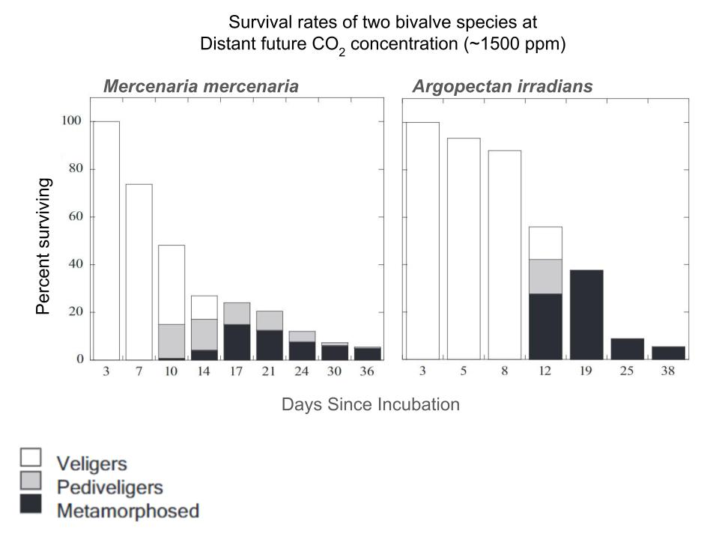
Getting comfortable with your data table:
- What is shown on the X-axis? ________days since incubation___________________________
- What is shown on the Y-axis? _________percent surviving______________________________
- Why are there two data tables on this page (how do they differ)?The graphs represent two different bivalve species and their survival rates at distant CO₂ concentrations
Analysis:
- After 36 days, what percentage of Mercenaria mercenaria are still alive?__15%________________
- After 38 days, what percentage of Argopecten irradians are still alive? ____20%________________
- How would you summarize the data from the tables in a single sentence?
At distant future CO₂ concentrations, 15% of clams and 20% of scallops survive until metamorphosis
Make connections (answer after completing your other data table):
- How do the outcomes in this data table compare to the data tables (Table 3) on your other sheet?
When this data is compared to Data Table 3, it shows that fewer clams and scallops survive until metamorphosis at distant future CO₂ concentrations than they do at projected future CO₂ concentrations. In both cases, survival rates are low.
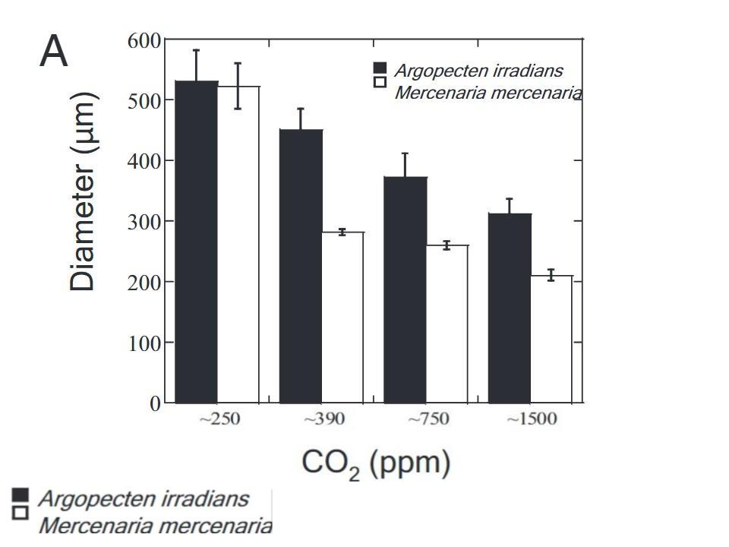

Getting comfortable with your data table:
- What is shown on the X-axis? ____CO₂ concentration in parts per million________________
- What is shown on the Y-axis? _____Diameter of shellfish in millimeters_______________________
- What would be a good title for this graph? Impact of CO₂ concentration on shellfish diameter (or growth)________
Analysis:
- Which species, Mercenaria mercenaria or Argopecten irradians, shows a greater sensitivity (impact from) to the change in CO₂? Argopectens irradians Explain your answer: Argopecten irradians (scallop) experiences a sharper drop-off in shell diameter at first, but Mercenaria mercenaria (hard clam) experiences steeper decreases in shell diameter at higher concentrations.
- How would you summarize the data from the table in a single sentence?
As the CO₂ concentration in seawater increases, shellfish diameter decreases.
Make connections (answer after completing your other data table):
- How do the outcomes in this data table compare to the data tables (Table 6) on your other sheet?
When looking at Data Table 6, we can see that both shell diameter and shell thickness decrease with increased CO₂ concentrations.

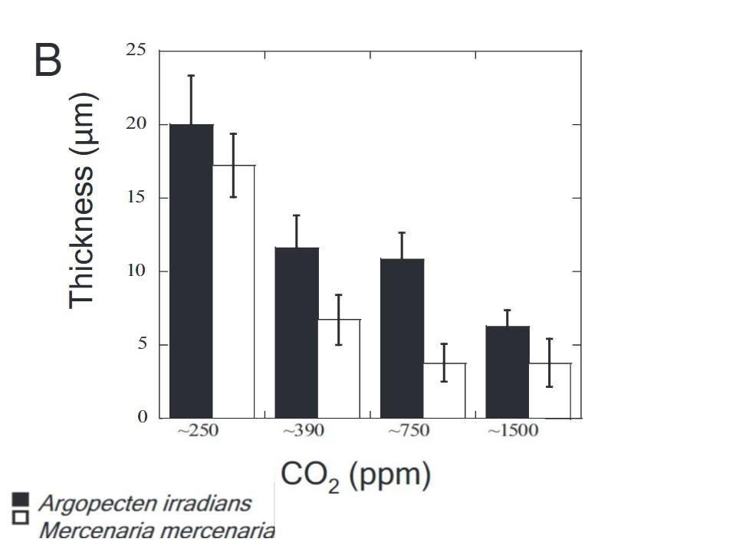

Getting comfortable with your data table:
- What is shown on the X-axis? ____CO₂ concentration in parts per million________________
- What is shown on the Y-axis? _____Thickness of shellfish in micrometers_______________________
- What would be a good title for this graph? Impact of CO₂ concentration on shell thickness________
Analysis:
- Which species, Mercenaria mercenaria or Argopecten irradians, shows a greater sensitivity (impact from) to the change in CO₂? Argopectens irradians Explain your answer: Argopecten irradians (scallop) experiences a sharper drop-off in shell thickness at first, but Mercenaria mercenaria (hard clam) experiences steeper decreases at higher concentrations.
- How would you summarize the data from the table in a single sentence?
As the CO₂ concentration in seawater increases, shell thickness decreases.
Make connections (answer after completing your other data table):
- How do the outcomes on this data table compare to the data tables (Tables 5 and 6) on your other sheet?
When comparing data tables 5 and 6, we can see that both shell diameter and shell thickness decrease as CO₂ concentrations increase.
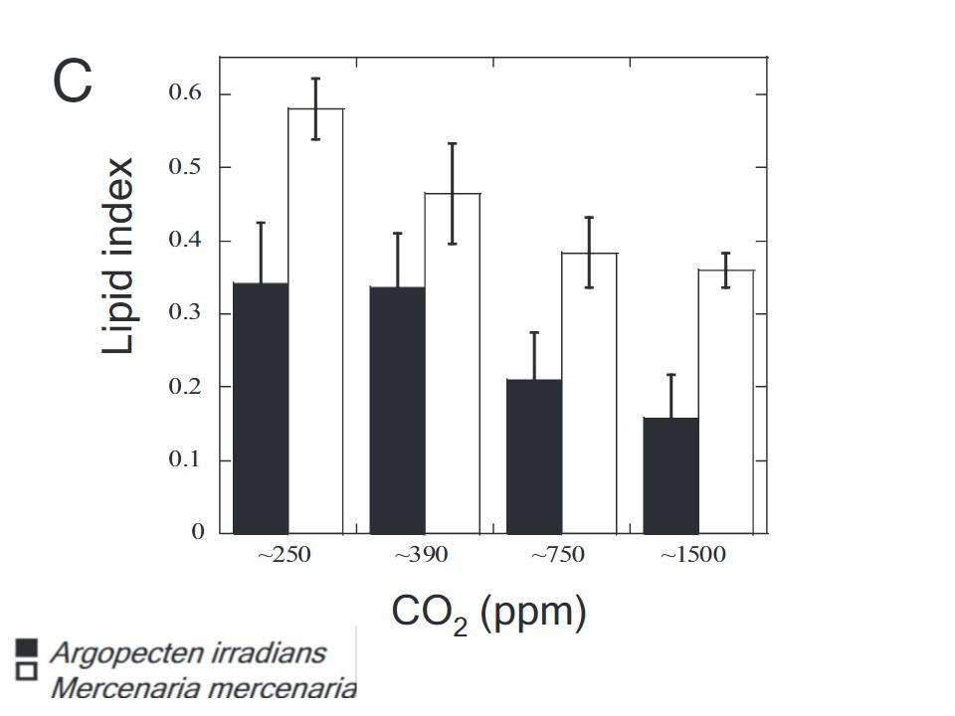

Getting comfortable with your data table:
- What is shown on the X-axis? ____CO₂ concentration in parts per million________________
- What is shown on the Y-axis? _____Lipid index_______________________
- What would be a good title for this graph? Impact of CO₂ concentration on shellfish lipid index
Analysis:
- Which species, Mercenaria mercenaria or Argopecten irradians, shows a greater sensitivity to the change in CO₂? Mercenaria mercenaria Explain your answer: Mercenaria mercenaria (clam) experiences a sharper drop-off in their lipid content at first, but Argopecten irradians (scallop) experiences steeper decreases at higher concentrations.
- How would you summarize the data from the table in a single sentence?
As the CO₂ concentration increases, the lipid content in a hard clam or scallop decreases.
Make connections (answer after completing your other data table):
- How do the outcomes on this data table compare to the data tables (Tables 7 and 8) on your other sheet?
When comparing Data Table 7 with Data Table 8, we can see that both shell composition and lipid index decrease with increased CO₂ concentrations.
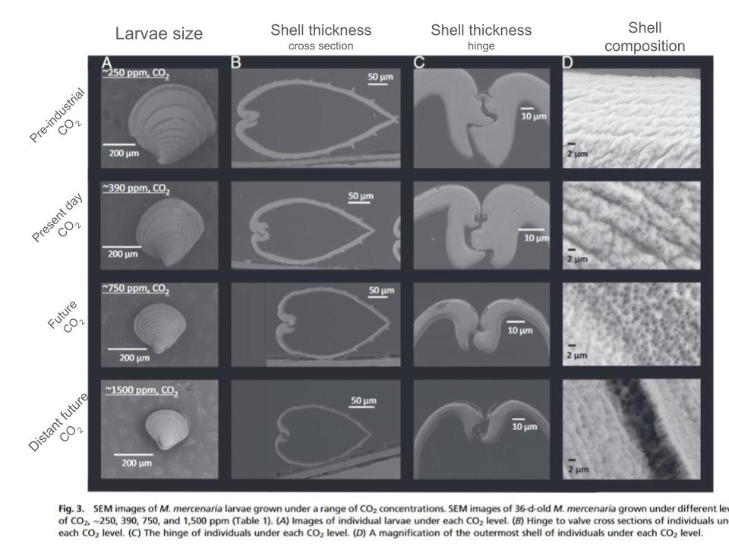
Getting comfortable with your data table:
- Each column (vertical) shows a different view of the Mercenaria mercenaria (hard clam) shell. What are the four views shown?
A) Larvae from above, B) Cross section of shell, C) Cross section of hinge, D) Up close view of shell
- Each row (horizontal) shows how the shells appeared after being treated to different conditions. What are the four conditions shown?
CO₂ concentrations during pre-industrial, present day, future, and distant future time.
- What would be a good title for this graph?
The impact of CO₂ concentration on shell size and quality.
Analysis:
- How would you summarize the data from the table in a single sentence?
Increasing CO₂ concentrations negatively impact shell size and quality.
Make connections (answer after completing your other data table):
- How do the outcomes in this data table compare to the data tables (Table 7) on your other sheet?
When looking at data table 7, we can see that both shell composition and quality, as well as lipid index, decrease with increased CO₂ levels.

