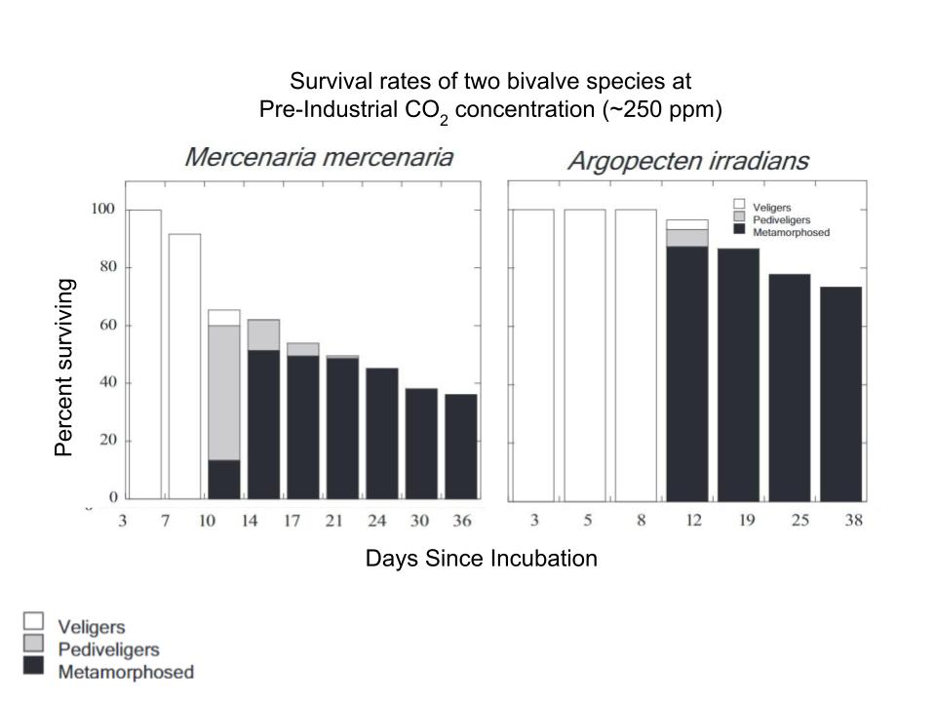
Getting comfortable with your data table:
- What is shown on the X-axis? __________________________________________________________
- What is shown on the Y-axis? __________________________________________________________
- Why are there two data tables on this page (how do they differ) ? __________________________________________________________________________________

Analysis:
- After 36 days, what percentage of Mercenaria mercenaria are still alive?_________________________
- After 38 days, what percentage of Argopecten irradians are still alive? __________________________
- How would you summarize the data from the tables in a single sentence?

Make connections (answer after completing your other data table):
- How do the outcomes on this data table compare to the data tables on your other sheet?

Getting comfortable with your data table:
- What is shown on the X-axis? __________________________________________________________
- What is shown on the Y-axis? __________________________________________________________
- Why are there two data tables on this page (how do they differ) ? __________________________________________________________________________________

Analysis:
- After 36 days, what percentage of Mercenaria mercenaria are still alive?_________________________
- After 38 days, what percentage of Argopecten irradians are still alive? __________________________
- How would you summarize the data from the tables in a single sentence?

Make connections (answer after completing your other data table):
- How do the outcomes on this data table compare to the data tables on your other sheet?

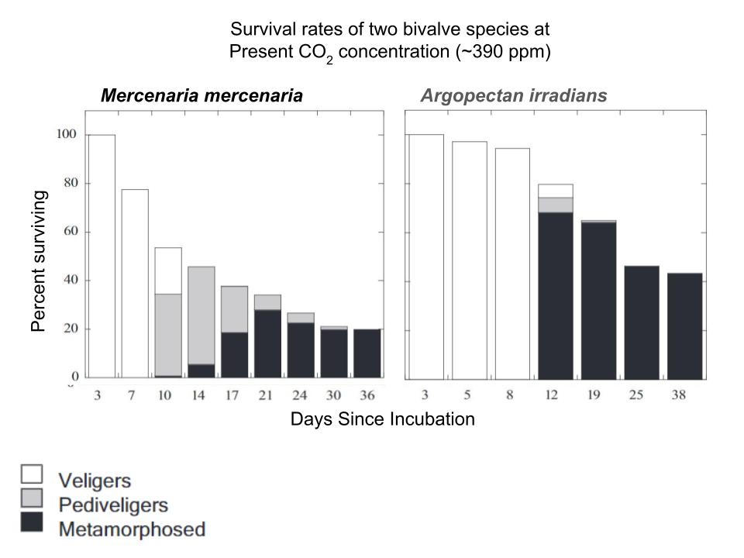

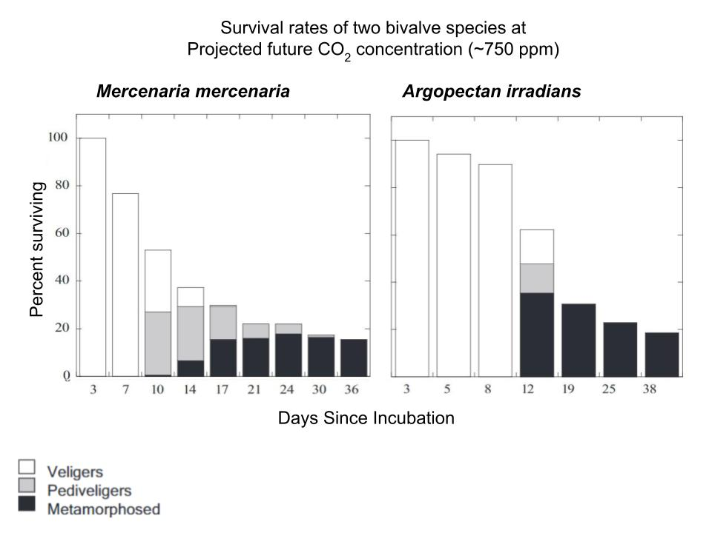

Getting comfortable with your data table:
- What is shown on the X-axis? __________________________________________________________
- What is shown on the Y-axis? __________________________________________________________
- Why are there two data tables on this page (how do they differ) ? __________________________________________________________________________________

Analysis:
- After 36 days, what percentage of Mercenaria mercenaria are still alive?_________________________
- After 38 days, what percentage of Argopecten irradians are still alive? __________________________
- How would you summarize the data from the tables in a single sentence?

Make connections (answer after completing your other data table):
- How do the outcomes on this data table compare to the data tables on your other sheet?

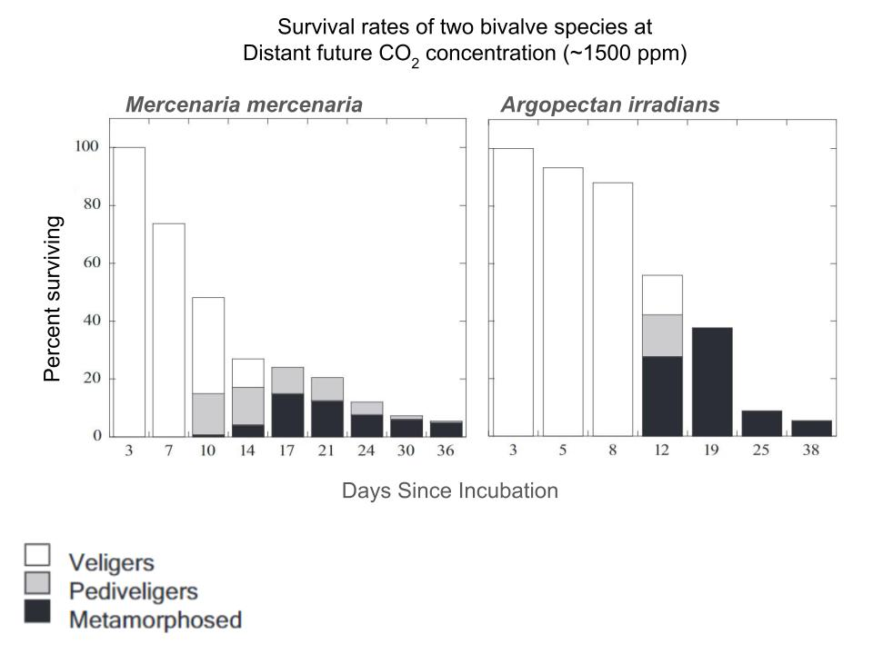
Getting comfortable with your data table:
- What is shown on the X-axis? __________________________________________________________
- What is shown on the Y-axis? __________________________________________________________
- Why are there two data tables on this page (how do they differ) ? __________________________________________________________________________________

Analysis:
- After 36 days, what percentage of Mercenaria mercenaria are still alive?_________________________
- After 38 days, what percentage of Argopecten irradians are still alive? __________________________
- How would you summarize the data from the tables in a single sentence?

Make connections (answer after completing your other data table):
- How do the outcomes on this data table compare to the data tables on your other sheet?

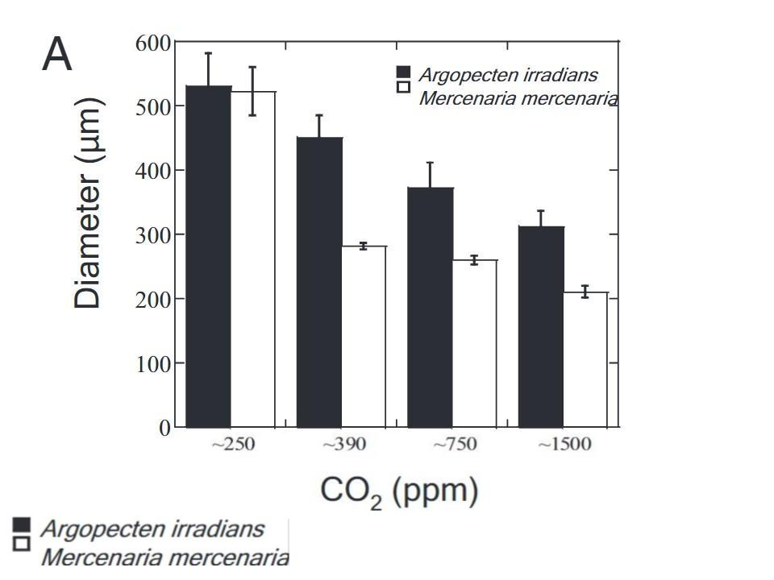

Getting comfortable with your data table:
- What is shown on the X-axis? __________________________________________________________
- What is shown on the Y-axis? __________________________________________________________
- What would be a good title for this graph? __________________________________________________________________________________

Analysis:
- Which species, Mercenaria mercenaria or Argopecten irradians, shows a greater sensitivity to the change in CO₂ ?______________________Explain your answer: ______________________________ __________________________________________________________________________________
- How would you summarize the data from the table in a single sentence?

Make connections (answer after completing your other data table):
- How do the outcomes on this data table compare to the data tables on your other sheet?

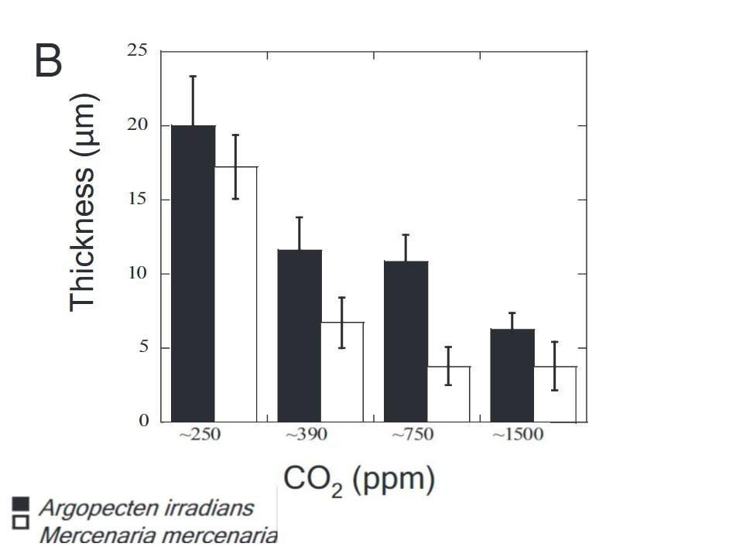
Getting comfortable with your data table:
- What is shown on the X-axis? __________________________________________________________
- What is shown on the Y-axis? __________________________________________________________
- What would be a good title for this graph? __________________________________________________________________________________

Analysis:
- Which species, Mercenaria mercenaria or Argopecten irradians, shows a greater sensitivity to the change in CO₂ ?______________________Explain your answer: ______________________________ __________________________________________________________________________________
- How would you summarize the data from the table in a single sentence?

Make connections (answer after completing your other data table):
- How do the outcomes on this data table compare to the data tables on your other sheet?

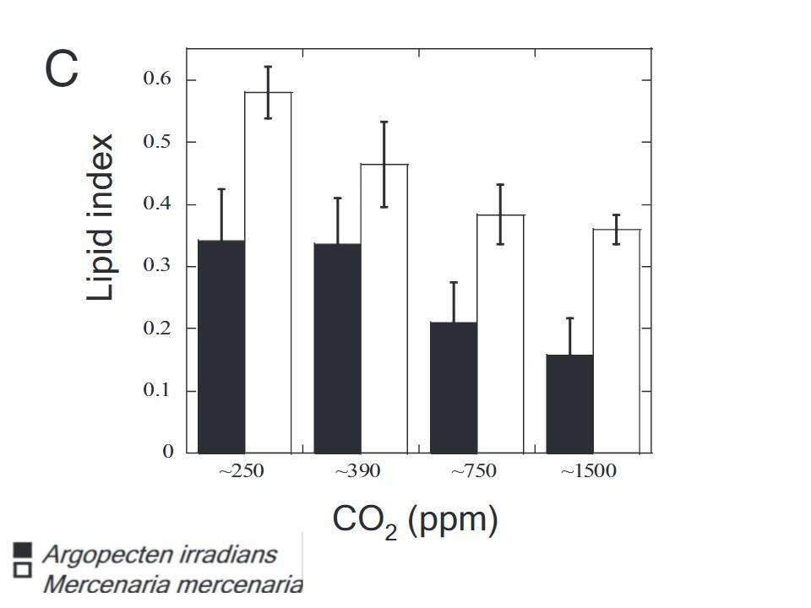

Getting comfortable with your data table:
- What is shown on the X-axis? __________________________________________________________
- What is shown on the Y-axis? __________________________________________________________
- What would be a good title for this graph? __________________________________________________________________________________

Analysis:
- Which species, Mercenaria mercenaria or Argopecten irradians, shows a greater sensitivity to the change in CO₂ ?______________________Explain your answer: ______________________________ __________________________________________________________________________________
- How would you summarize the data from the table in a single sentence?

Make connections (answer after completing your other data table):
- How do the outcomes on this data table compare to the data tables on your other sheet?

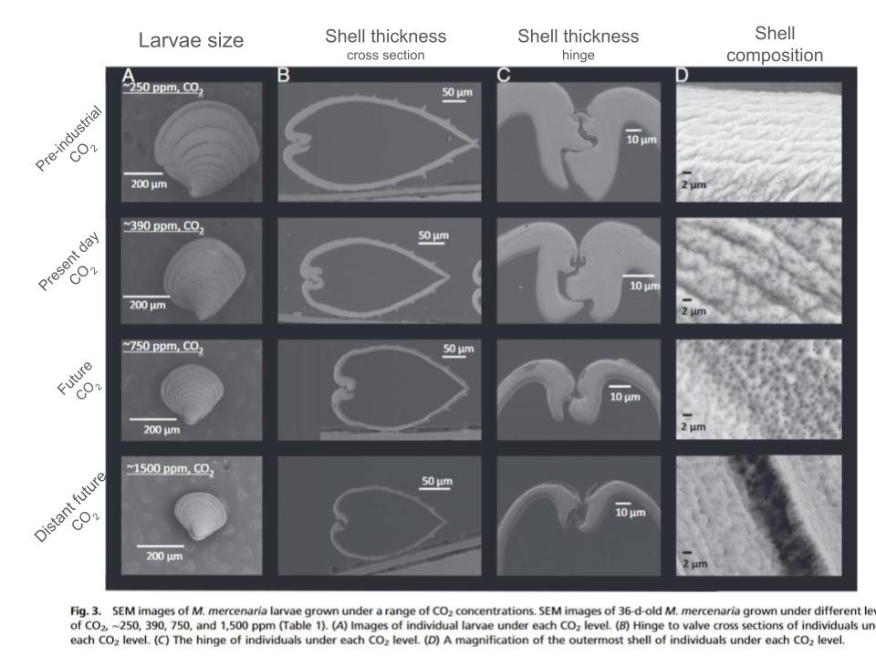
Getting comfortable with your data table:
- Each column (vertical) shows a different view of the Mercenaria mercenaria (hard clam) shell. What are the four views shown?

- Each row (horizontal) shows how the shells appeared after being treated to different conditions. What are the four conditions shown?

- What would be a good title for this graph?

Analysis:
- How would you summarize the data from the table in a single sentence?

Make connections (answer after completing your other data table):
- How do the outcomes on this data table compare to the data tables on your other sheet?

