Name____________________________________ Date______ Class____
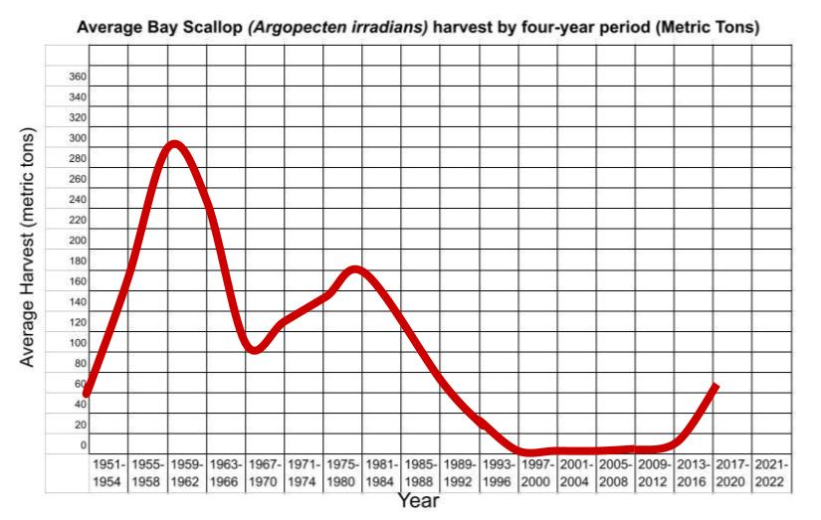
Answer Key: The Case of the Vanishing Scallops (Student Worksheet 1)

Sample Answer (Observations):

  - The scallop harvest has generally decreased (or fluctuated significantly, depending on the data) over the time period shown.
  - There was a sharp decline in the harvest during certain years (or after a specific point in time).
  - The harvest levels at the end of the period are much lower than the levels at the beginning.

Thinking deeply about data:

- What does "scallop harvest" mean? Who harvests scallops? For what purpose?

Answer:

  - Scallop harvest means the collection or catching of scallops, usually for consumption or sale.
  - Who harvests scallops? Commercial fishermen/dredgers, recreational fishers, and sometimes researchers (for data collection).
  - For what purpose? Primarily for human consumption (food) and commercial sale; secondarily for bait, or scientific research.
- Does a changing scallop harvest necessarily imply a decline in the scallop population? What else, besides declining population, could result in smaller harvests?

Answer: No, a changing (especially declining) scallop harvest does not necessarily imply a decline in the scallop population.

  - Other factors that could result in smaller harvests:
    - New or stricter fishing regulations (e.g., shorter season, smaller catch limits, protected areas).
    - Economic factors (e.g., lower market demand, low prices, high fuel costs making fishing unprofitable).
    - Bad weather or environmental conditions that make fishing difficult or unsafe.
    - A decrease in the number of commercial fishers or boats operating.
    - Scallop populations migrating to areas outside the typical harvesting grounds.
- What additional information would you need to determine if lower scallop harvests were due to declining populations of scallops?

Answer:

  - Direct population estimates (e.g., scientific surveys counting scallops per square meter in known beds).
  - Catch per Unit Effort (CPUE) data (the amount of scallops caught for a given amount of fishing effort, such as pounds caught per hour of dredging). A declining CPUE strongly suggests population decline, even if regulations haven't changed.
  - Information on fishing effort (e.g., number of boats fishing, total hours spent fishing).
  - Data on the size or age distribution of the harvested scallops (a population in decline might have fewer larger, older scallops).
  - Environmental data (water quality, pH, temperature, presence of disease) to see if external factors are stressing the population.

Thinking deeply about the problem:

- Think about what you just watched. Develop 5 pertinent questions about the scallop die-off that could help you discover:
  - The cause of the die-off and how to prevent it from recurring
  - The effects of the die-off on the surrounding ecosystem

Sample Answer (Student questions should be specific and focus on potential variables):

  - Water Quality/Cause: Was there a significant change in water temperature, salinity, or dissolved oxygen levels immediately before or during the die-off event?
  - Toxins/Cause: Was a harmful algal bloom (red tide) present, or were elevated levels of pollutants (e.g., pesticides, nitrogen) detected in the bay waters during that time?
  - Disease/Cause: Did pathological examination of the dead or dying scallops reveal the presence of a specific pathogen, parasite, or disease?
  - Ecosystem Effect: How has the decline in scallops (a filter feeder) affected the water clarity, phytoplankton levels, and overall health of the eelgrass beds in the area?
  - Prevention/Recovery: Are there other populations of shellfish (clams, oysters) or other animals (crabs, fish) showing signs of stress or decline that could indicate a larger environmental problem that needs to be addressed to prevent future die-offs?

