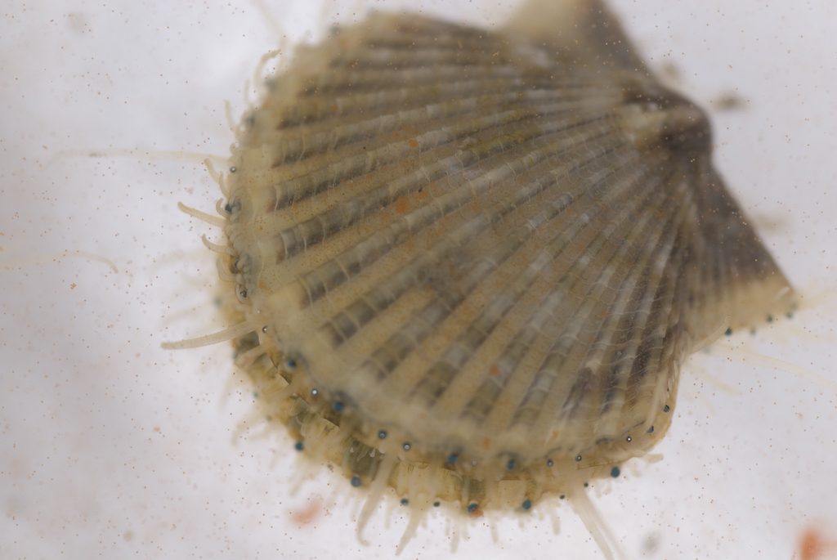Argopecten irradians (Atlantic Bay Scallop), a species of scallop found in Long Island. Credit: tjdatsrt/Flickr/CC BY-NC 2.0
Stephen Tomasetti - Science Friday
If you jump in your car in Manhattan and drive about 85 miles east out to Long Island, you’ll reach a spot where the island forks into two spits of land, the remains of ancient glaciers as they retreated thousands of years ago.
Between these lies the Peconic Bay, which opens out to the Atlantic Ocean. The Bay, like much of the waters around Long Island, has been losing its shellfish at an alarming rate. Already, 90% of the lobsters in Long Island Sound have disappeared. And now, there’s a die-off in scallops.
Over the last two years, the Peconic Bay has lost more than 90% of its scallops—bad news for a community where harvesting shellfish has long been an important part of the economy. Researchers are scrambling to discover why this is happening. Is it predation, climate change, illness—or maybe a combination of everything?
Joining Ira to talk about his research with the Peconic Bay’s scallops is Stephen Tomasetti, PhD candidate in marine science at Stony Brook University in Southampton, New York. They talk about what could be causing this devastation, and how a “scallop FitBit” could shed light into how these shellfish are feeling.
IRA FLATOW: This is Science Friday. I’m Ira Flatow. If you jump in your car in Manhattan and drive about, oh, 85 miles east out to Long Island, you’ll reach a spot where the island forks into two spits of land, the remains of ancient glaciers as they retreated thousands of years ago. In between the north and southern forks is the Peconic Bay which opens out to the Atlantic Ocean. The Bay, like much of the waters around Long Island, has been losing its shellfish at an alarming rate.
First, there was the loss of 90% of the lobsters in Long Island sound. And now we have a die-off in scallops. This is bad news for a community where harvesting shellfish has long been an important part of the local economy. Here to discuss the science, the biology behind this is Stephen Tomasetti, PhD candidate in marine science at Stony Brook University in South Hampton, New York. Welcome to Science Friday.
STEPHEN TOMASETTI: Hi, thanks for having me. Happy to be here.
IRA FLATOW: When did people notice that the scallop populations were dwindling?
STEPHEN TOMASETTI: Well, these die offs have now happened two years in a row before the start of the scallop fishing season, which begins in November. The first reports were sometime around early August of 2019. And local bay men were reporting either cluckers– which are really just dead scallops, they’re open shells with no muscle tissue– or seeing no scallops at all. And this die off was then confirmed in October of 2019 through a number of dive surveys that were done by Dr. Steve Tuttle back in a group of researchers from both Stony Brook and Cornell.
IRA FLATOW: And how much of a die off is it?
STEPHEN TOMASETTI: Well, both years it’s been quite dramatic. We’re talking something around 95% decrease in 2019. And now we’re about 99% decrease in 2020.
IRA FLATOW: And are these baby scallops that just don’t thrive or are they adult ones that just die?
STEPHEN TOMASETTI: Great question. The bay scallops have very unique life histories. They usually live for up to two years. And they spawn or reproduce just a few times in their lifetime. So typically at times in the summer, they release their eggs and sperm in the water. That’s where fertilization happens. And then the larvae sort of drift around for a while before they become juveniles and attach to seagrass blades where they grow.
We call these baby scallops bugs. And we’re finding bugs each year in our surveys. So biologically, the scallops are doing what they’re supposed to do, that is adults are surviving long enough to spawn. But then sometime in that window between the spawning events and the start of the fishing season, the mortality is happening among the adults.
IRA FLATOW: And is this a problem just in the New York waterways, or are populations going down everywhere?
STEPHEN TOMASETTI: Good question. We know that bay scallops historically have been on the decline if we look at compared to the ’70s until today. But in terms of this sort of drastic decline, we’ve seen that happen before in New York in the past, in the ’80s, due to harmful algal blooms. But currently these iconic estuary scallops are all I know of that are declining so rapidly. I know that Cape Cod populations by all accounts seem to have a normal year last year, whereas we did not.
IRA FLATOW: OK, so let’s talk about what you might think is causing this. Any guesses? Could it be climate change? Could it be, what?
STEPHEN TOMASETTI: Well, we’re putting together the pieces in this puzzle now. I should say that this has been a very collaborative effort. After that first die off, our local Peconic estuary program, which is affiliated with the EPA put together a technical advisory committee. And now after going through a second year of a summer die off, we know a lot more. And it seems to boil down to a few different things. And the two things are energetics and potentially also predation.
So when marine biologists study environmental stress, we think a lot about bio-energetics. We try to learn about what’s called an organism’s aerobic scope, which really just means the amount of extra energy that’s available for spawning, for growth, for immune defense. And when environmental conditions become stressful, like say for instance due to high temperature or low dissolved oxygen levels, then that surplus energy shrinks. And if there becomes a point when the animal needs more energy than it has reserves, it can lead to mortality.
So we already from different lab studies that bay scallops are particularly sensitive in terms of mollusks in our Bay. And we also know that in 2019 we had anonymously high temperatures for the summer. On top of that, Stony Brook’s marine animal disease lab is also looking at a parasite that could have added additional stress.
So there’s a lot going on. But the other side is that it also could be predators. Cownose rays have been spotted last year in multiple Long Island bays. And these are warm water predators that are now being found in our local waters in the summers.
So to answer your question about climate change, I think it is very likely. There’s a great study that shows the warming climate in our region has led to not only higher average water temperatures throughout the year, but also a higher frequency of extremely hot summer days, which we know can be very stressful. So you combine that with these other localized issues. And now the scallops are dealing with multiple difficult stressors at the same time.
But even if it’s not environmental stress and its predators, like I said before, those cownose rays are warm water predators. And their summer migrations are reaching further and further north. And they may be coming in more and more numbers. So either way you look at it, it seems climate change is probably playing an important role here.
IRA FLATOW: Interesting, because climate change also has a factor where the water– because there’s so much CO2 in the air, the CO2 is being dissolved in the water and acidifying the water, which marine creatures don’t like either. Could that also be a factor?
STEPHEN TOMASETTI: Yeah, it’s a great point. That’s mainly what I work on to be honest is hypoxia and acidification. And particularly, calcified organisms are susceptible to these types of stress. You see it more often in baby scallops and larvae where they’re trying to develop a shell, because it becomes very difficult to develop that early shell when you have acidified waters. But since these are adults that are typically dying, even though acidification might be playing a role in the issue, it’s likely not the main, or only driver of mortality.
IRA FLATOW: You know, lobsters used to thrive in Long Island Sound. And 90% of those lobsters are now gone. And the word is that they have migrated North toward New England. Could this happen to the scallops also?
STEPHEN TOMASETTI: Well, there are scallops up and down the East coast, going down to Florida all the way up to the New England area. And there’s different subspecies of scallops. So some of them are more adapted to certain temperature regimes. And we might see either a restriction in the scallop range, if temperature is playing a very important factor here, or you could see an expansion northward, like what you just mentioned with the lobsters.
IRA FLATOW: And of course, this must be a tremendous disappointment and social impact, an economic impact to the Long Island economy to the fishermen.
STEPHEN TOMASETTI: Oh, yes, the region here provides lots of both jobs and revenue to local fishermen. So these are economically important species. But they’re also an environmentally important species. Scallops are bivalves, and they have two shells like oysters and clams. And along with other bivalves they play an important role in the environment because they filter feed. So they remove microscopic algae from the water column. Which is important because in many places if this algae isn’t efficiently removed and it eventually dies and it gets broken down by microbes in the water, that process will deplete the dissolved oxygen in the water and leads to sort of poor water quality.
IRA FLATOW: They are sort of like the ocean’s vacuum cleaner.
STEPHEN TOMASETTI: Exactly, so these animals help to protect this environment they live in.
IRA FLATOW: It’s my understanding that you’re studying the scallops with a scallop FitBit. You got tell me about this. What does it look like? And what information can you get out of a scallop FitBit?
STEPHEN TOMASETTI: Yes, basically scallops FitBits look like a bunch of jumbled wires. But they’re actually a reflective optical infrared sensor. And we use this to measure scallop heartbeat rates. And they’re water proofed and then glued to the surface of a scallop shell just above where the heart is. And then I connect them to a microcontroller board, which is like a small computer. And that logs data onto an SD card, and it all goes in the bay together, so all of this equipment with the scallops.
And the way it works is the sensor both shines but also detects infrared light. And so every time that scallop heart contracts, the amount of reflected infrared light that’s detected by the sensor changes. So when I measure that over a period of time, I can see these regular oscillations in the amount of reflected light. And then I can use that to quantify the scallop heartbeat rates.
IRA FLATOW: And what does a scallop heartbeat sound like?
STEPHEN TOMASETTI: Well, they typically beat at somewhere between 15 to about 30 beats per minute when they’re in resting conditions. But then what’s cool about this method is that we learn how the scallop is responding to changes in its environment. So we’re also simultaneously measuring the water. And if we might see a scallop heart rate even triple under low oxygen conditions that they might be in for let’s say 10 hours, and so that heartbeat rate can then be used as a measure of how quickly they’re using up their energy reserves.
IRA FLATOW: Interesting, can you apply your little FitBit to other sick marine creatures?
STEPHEN TOMASETTI: Yes, in fact, people have used the same technology to look at crabs as well, so fiddler crabs and also blue crabs. And people have used it for other bivalves as well.
IRA FLATOW: One last question for you and it’s sort of my blank check question. And if I had a blank check I would give it to you. But of course, we’re not in the same room. If you could get the answer to anything, what would you like to know? And the blank check means you can spend your money on any kind of material, resources, or whatever? What’s the thing you want to know most?
STEPHEN TOMASETTI: That’s great. Well, I’ll give you a modest answer because to be honest, the main question I would like to answer is the question that’s driving this chapter of my dissertation research. So as I mentioned before, I’m very interested in both the threshold temperatures, so high temperatures and low dissolved oxygen levels at which these scallops are adversely affected.
So for me, the big picture is really about, how does the timing of these spawning events, which we know are a very energy intensive process, impact their vulnerabilities to stress from high temperatures and low oxygen? So is it that this spawning event is occurring at a certain time in the summer, is it really exhausting their energy reserves? I’d like to get an answer to that question.
IRA FLATOW: Well, we hope you do. And we wish you good luck on your dissertation.
STEPHEN TOMASETTI: Thank you very much.
IRA FLATOW: Send them a little copy of this interview on Science Friday, maybe that will help you with the committee.
STEPHEN TOMASETTI: Oh, I hope so.
IRA FLATOW: Stephen Tomasetti, PhD candidate in marine science at Stony Brook University in South Hampton, New York.

